Anexo IV – Sistemas TIC de gestión de la IC

# 1. Modos de Operación

La prestación del servicio esencial en la PR requiere la operación mediante los mecanismos existentes, y bajo las adecuadas condiciones de continuidad, calidad y seguridad, de los procesos que en ella se desarrollan. Se cuenta con los siguientes modos de operación, así como de interacción en algunos casos limitada, conformando los servicios internos indispensables para el adecuado funcionamiento de la PR.

* Local

La operación sobre los sistemas DCS, SSA y ESD sólo se puede realizar en el ámbito local de la Planta de Regasificación y en particular desde el Centro de Control principal y el del Jetty, por medio de las consolas existentes. Estos sistemas interactúan con los elementos de campo y sistemas auxiliares que controlan los procesos industriales. Cualquier actuación directa sobre los equipos industriales de la planta, como la apertura o cierre manual de válvulas, produce alarmas en los sistemas de control que son monitorizadas por los operadores. Esta operativa se corresponde con el Servicio de Operación Local de la Planta.

El Sistema Montrel para el control de los surtidores que permiten la carga de camiones cisterna con GNL, es controlado localmente desde la caseta ubicada junto a dichos surtidores. Dicho sistema dispone de una interfaz interna con el Sistema de Control de la Planta para proveerle información sobre el proceso de carga de cisternas, pero que no permite su operación (sólo permisivos). Esta operativa se corresponde con el Servicio de Operación Local del Cargadero de Cisternas.

* Otros accesos

Algunas interfaces permiten acceder desde el exterior a parte de los Sistemas de Control o facilitar a los Sistemas de Administración de la Planta información sobre la operación:

* Al proveedor Montrel se le habilita una conexión para que acceda remotamente para el mantenimiento del Sistema de Control del cargadero vía VPN.
* Yokogawa se conecta a través de una VPN previa conexión física habilitada por SAGGAS para el mantenimiento de los Sistemas de Control.
* Comunicación por Webservice entre el servidor Montrel y el SL-ATR de Enagás para la información de la carga de cisternas autorizadas.
* Unos servidores OPC recogen señales del proceso y la operación de la planta y los almacenan actuando como buffers para que posteriormente los servidores PI ubicados en la red de gestión recojan la información. El personal de administración accede al servidor PI para tareas de gestión.
* Indra accede remotamente para gestionar el servidor PI mediante un enlace punto a punto.

# 2. arquitectura y equipamiento del sistema de control

La arquitectura del sistema de control de la PR se basa en una red local que comunica los sistemas con los Centros de Control y redes de comunicación para la conexión con PLCs basadas en protocolos MODBUS/FIELDBUS FOUNDATION. Finalmente, la comunicación entre los PLCs y los dispositivos de campo asociados a ellos es analógica.

Dos salas distribuidas en la instalación alojan diferentes componentes del equipamiento (racks de equipos y PLCs) que soportan los sistemas de control siendo la principal, la que alberga la mayor parte de los equipos, la conocida como FIR 1 (Field Instrumentation Room) ubicada en el Centro de Control principal y la secundaria la conocida como FIR 2, ubicada en el edificio del Jetty. La LAN de proceso comunica entre sí las salas mediante fibra óptica. Los equipos críticos para los sistemas de seguridad de la planta cuentan con redundancia a nivel de procesadores y fuentes de alimentación.

En una sala anexa a la sala de control principal se encuentra una sala con las estaciones de ingeniería para configurar los parámetros de los sistemas.

Una tercera sala de control en la caseta del cargadero aloja los equipos y PLCs del Sistema Montrel junto a las consolas de operación e ingeniería.

En la sala (centro) de control principal se ubican las siguientes tipologías de consolas o estaciones conectadas a la LAN de proceso, tal y como recoge la Figura 1:

* Estaciones de operación DCS/SSA: desde donde los operadores monitorizan y actúan sobre los procesos de carga/descarga, almacenamiento y regasificación.
* Consola del sistema de gestión eléctrica.
* Consola videocámaras.
* Panel de disparos del ESD (sistema de apagado automático).
* Consola para el sistema de carga/descarga del Jetty.

Adicionalmente, en la sala de control del Jetty también se cuenta con sistema de torres monitoras, sistema de guiado rápido, sistema de carga/descarga, PC de ayuda al atraque, PC cromatógrafo y videocámaras.

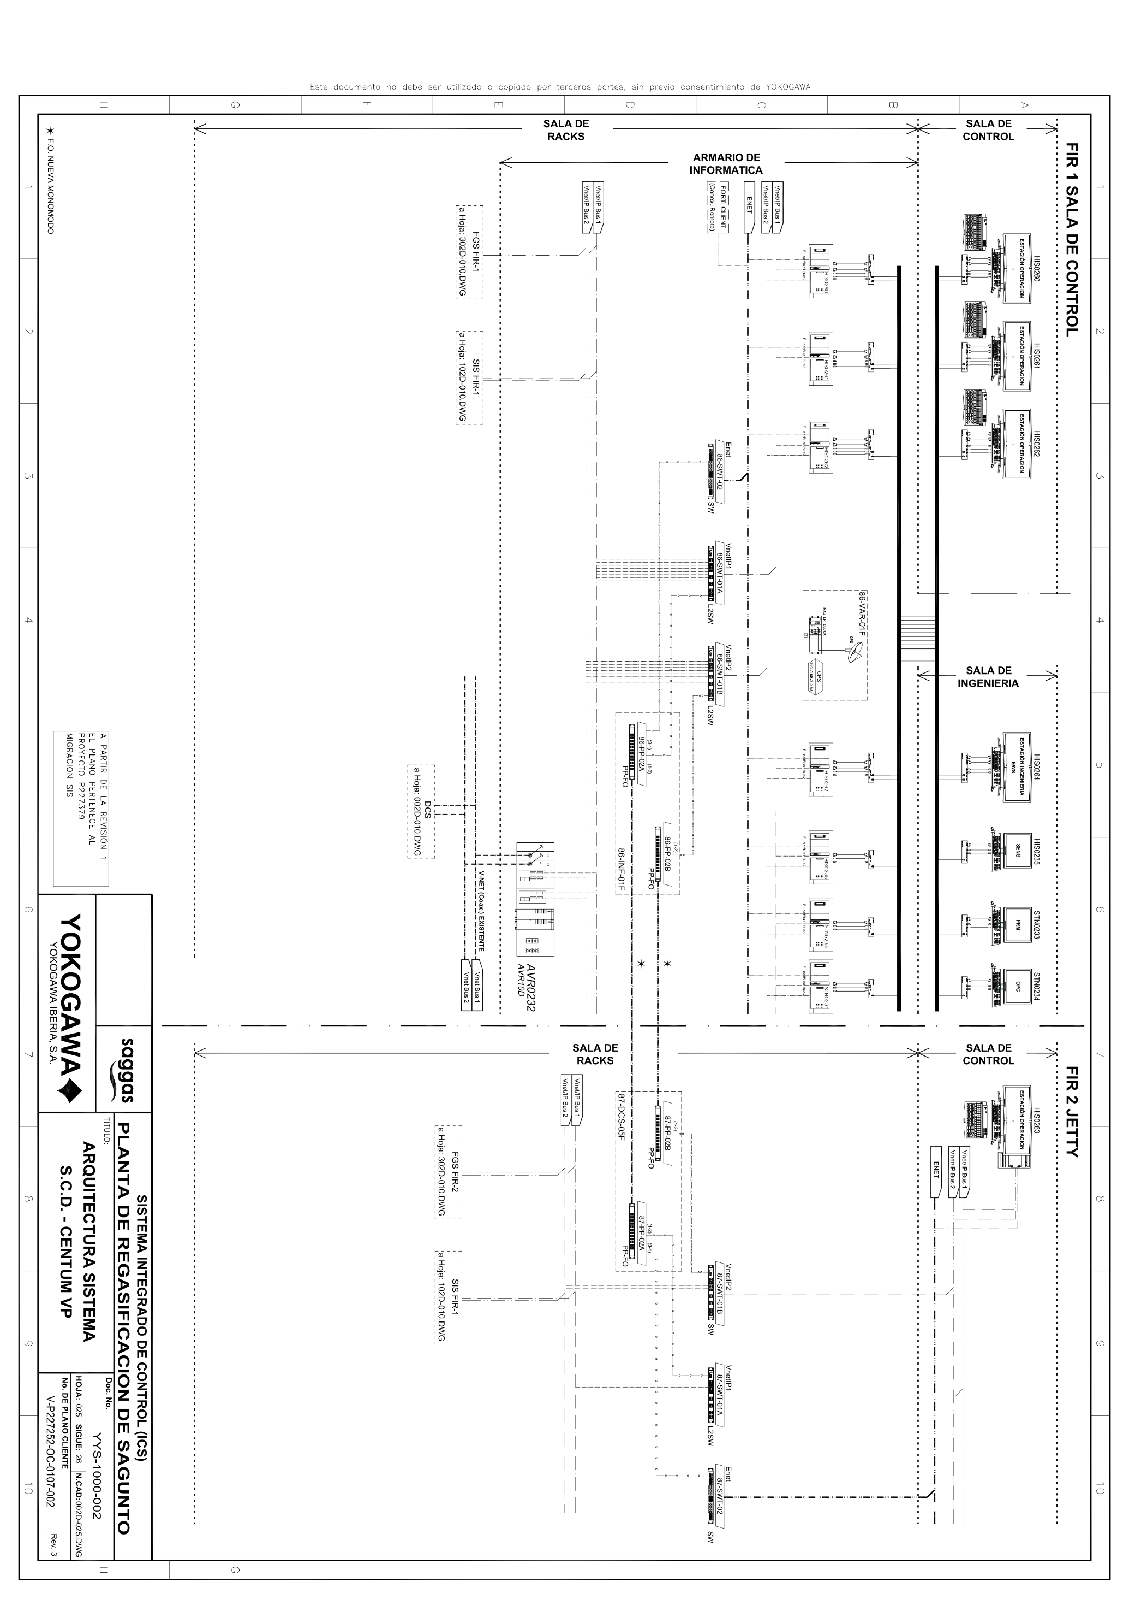

Figura 1 Arquitectura del Sistema de Control de la Planta de Regasificación

EQUIPAMIENTO HARDWARE PARA SISTEMAS DE CONTROL DCS, SIS, FGS Y ESD

|  |  |  |  |  |
| --- | --- | --- | --- | --- |
| CÓDIGO | DESCRIPCIÓN | FABRICANTE | MODELO | UBICACIÓN |
| HIS0260 | Estación de operación | HP | Z230 | FIR-1 |
| HIS0261 | Estación de operación | HP | Z230 | FIR-1 |
| HIS0262 | Estación de operación | HP | Z230 | FIR-1 |
| HIS0264 | Estación de ingeniería DCS (EWS) | HP | Z230 | FIR-1 |
| HIS0235 | Estación de ingeniería Prosafe RS (SENG) | HP | Z230 | FIR-1 |
| STN0233 | Estación PRM | HP | Z230 | FIR-1 |
| STN0234 | Estación OPC | HP | Z230 | FIR-1 |
| 86-SWT-02 | Switch red Ethernet | Netgear | GS724T | FIR-1 |
| 86-SWT-01A | Switch red VnetIP 1 | Hirschmann | MACH104-20TX-FR | FIR-1 |
| 86-SWT-01B | Switch red VnetIP 2 | Hirschmann | MACH104-20TX-FR | FIR-1 |
| 87-SWT-02 | Switch red Ethernet | Netgear | GS724T | FIR-2 |
| 87-SWT-01A | Switch red VnetIP 1 | Hirschmann | MACH104-20TX-FR | FIR-2 |
| 87-SWT-01B | Switch red VnetIP 2 | Hirschmann | MACH104-20TX-FR | FIR-2 |
| AVR010D | Router Vnet redundante | Yokogawa | BCVV0232 | FIR-1 |
| MASTER CLOCK | Sincronizador horario vía GPS |  |  | FIR-1 |

EQUIPAMIENTO SOFTWARE PARA SISTEMAS DE CONTROL DCS, SIS, FGS Y ESD

|  |  |  |  |  |
| --- | --- | --- | --- | --- |
| COGIGO | DESCRIPCIÓN | FABRICANTE | VERSION | USO |
| CENTUM VP | Administración y supervisión del DCS | Yokogawa | R6.03.00 | Estaciones de operación e ingeniería (EWS) |
| Prosafe RS | Administración sistemas SIS y FGS | Yokogawa | R4.02.00 | Estación ingeniera SIS y FGS (SENG) |
| Exa OPC | Interfaz comunicaciones con PI | Yokogawa | NTPKM01-C1* | Estación STN0234 |
| Release: R3.75.00 |
| PRM | Gestión Instrumentos HART | Yokogawa | R3.31.00 | Estación STN0233 |
| Windows 7 Pro | Sistema Operativo | Microsoft |  | Estaciones de operación e ingeniería. |

La arquitectura del sistema de control de la PR se basa en una red local que comunica los sistemas con los Centros de Control y redes de comunicación para la conexión con PLCs basadas en protocolos MODBUS/FIELDBUS FOUNDATION. Finalmente, la comunicación entre los PLCs y los dispositivos de campo asociados a ellos es analógica.

Dos salas distribuidas en la instalación alojan diferentes componentes del equipamiento (racks de equipos y PLCs) que soportan los sistemas de control siendo la principal, la que alberga la mayor parte de los equipos, la conocida como FIR 1 (Field Instrumentation Room) ubicada en el Centro de Control principal y la secundaria la conocida como FIR 2, ubicada en el edificio del Jetty. La LAN de proceso comunica entre sí las salas mediante fibra óptica. Los equipos críticos para los sistemas de seguridad de la planta cuentan con redundancia a nivel de procesadores y fuentes de alimentación.

En una sala anexa a la sala de control principal se encuentra una sala con las estaciones de ingeniería para configurar los parámetros de los sistemas.

Una tercera sala de control en la caseta del cargadero aloja los equipos y PLCs del Sistema Montrel junto a las consolas de operación e ingeniería, Figuras 2 y 3.

En la sala (centro) de control principal se ubican las siguientes tipologías de consolas o estaciones conectadas a la LAN de proceso, tal y como recoge la Figura 11:

* Estaciones de operación DCS/SSA: desde donde los operadores monitorizan y actúan sobre los procesos de carga/descarga, almacenamiento y regasificación.
* Consola del sistema de gestión eléctrica.
* Consola videocámaras.
* Panel de disparos del ESD (sistema de apagado automático).
* Consola para el sistema de carga/descarga del Jetty.

Adicionalmente, en la sala de control del Jetty también se cuenta con sistema de torres monitoras, sistema de guiado rápido, sistema de carga/descarga, PC de ayuda al atraque, PC cromatógrafo y videocámaras.

# arquitectura y equipamiento del sistema de cargadero

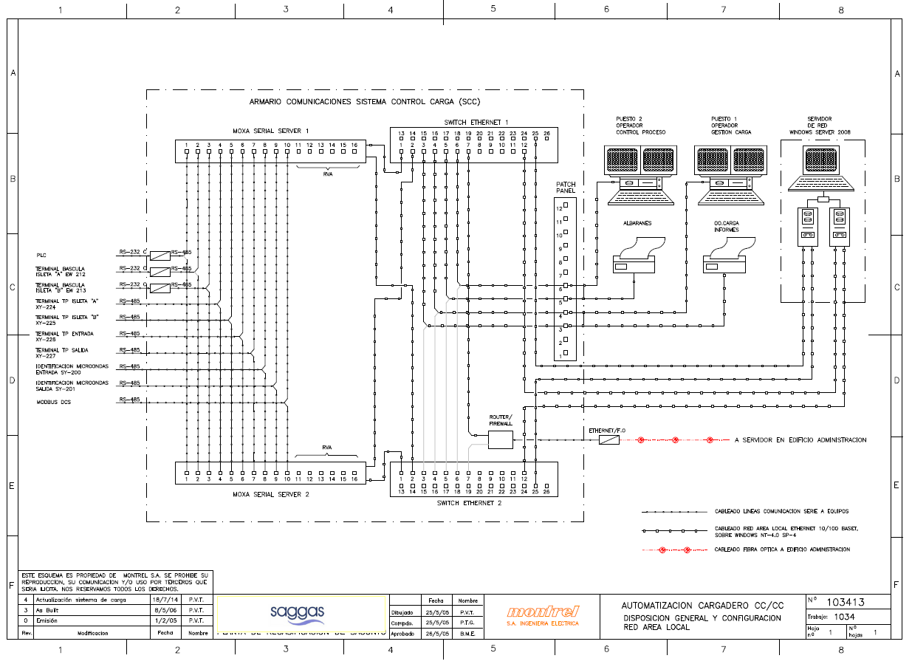

Figura 2 Arquitectura del Sistema de Carga de Cisternas de la Planta de Regasificación

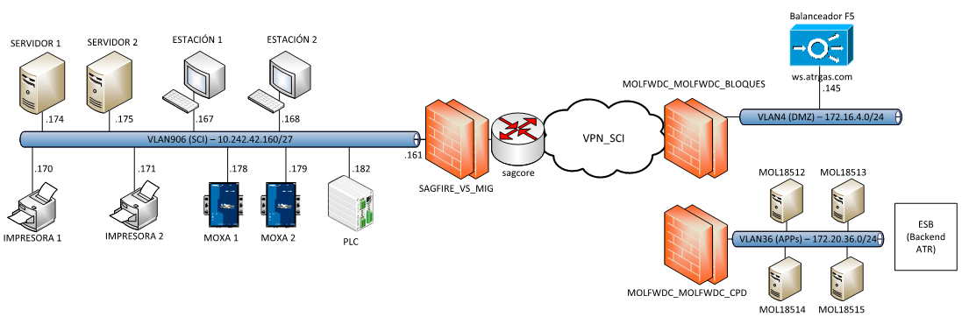

Figura 3 Sistema de carga de cisternas integrado en servicio SCI Enagas

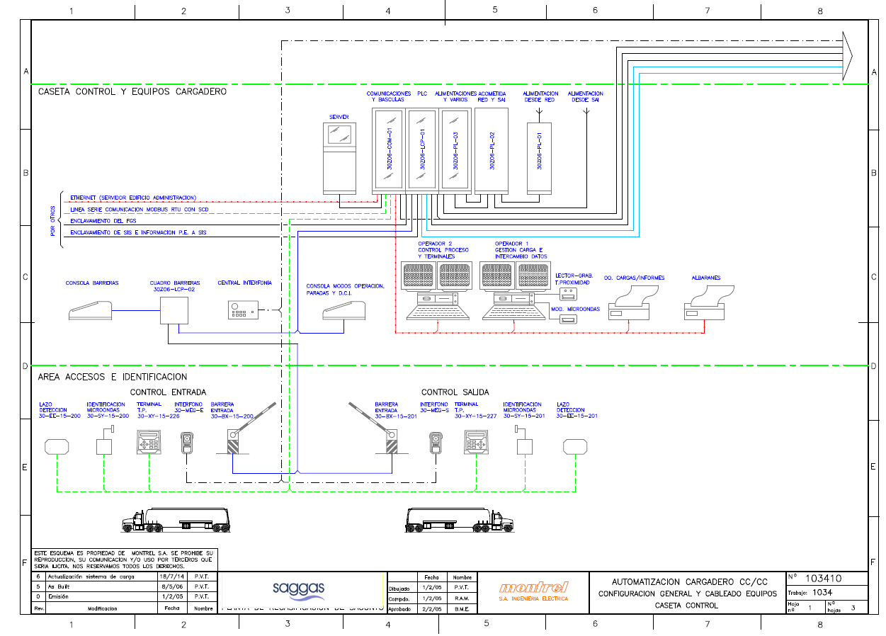

Figura 4 Configuración general Sistema de carga de cisternas

EQUIPAMIENTO HARDWARE PARA SISTEMAS DE CARGA DE CISTERNAS (MONTREL)

|  |  |  |  |  |
| --- | --- | --- | --- | --- |
| CÓDIGO | DESCRIPCIÓN | FABRICANTE | MODELO | UBICACIÓN |
| SERV01SAGGAS | Servidor principal | HP | ProLiant DL380p Gen8 Xeon E5-2640 | Cargadero cisternas |
| SERV02SAGGAS | Servidor backup | HP | ProLiant DL380p Gen8 Xeon E5-2640 | Cargadero cisternas |
| EST01SAGGAS | Estación de operación | HP | Compaq 6300 Pro, Core i5 3470 | Cargadero cisternas |
| EST02SAGGAS | Estación de operación | HP | Compaq 6300 Pro, Core i5 3470 | Cargadero cisternas |
| MOXA01 | Convertidor de puertos | MOXA | CN2650 | Cargadero cisternas |
| MOXA02 | Convertidor de puertos | MOXA | CN2650 | Cargadero cisternas |
| CSAGW0303_CISTERNAS | 2 Switches 48P en Stack | CISCO | VS-C2960X-48LPS-L V05 | Cargadero cisternas |
| IMPRESORA 1 | Impresora red | HP | LaserJet Enterprise M601n | Cargadero cisternas |
| IMPRESORA 2 | Impresora red | HP | LaserJet Enterprise M601n | Cargadero cisternas |
| IMPRESORA TARJETAS | Impresora red de tarjetas HID | Datacard | SD260 | Cargadero cisternas |

EQUIPAMIENTO SOFTWARE PARA SISTEMAS DE CARGA DE CISTERNAS (MONTREL)

| INVENTARIO SOFTWARE EN SERVIDOR PI |
| --- |
| SIMAC Gestion v1.0.0.0 - Montrel |
| SIMAC Sinopticos (SimacSin.Saggas) v1.0.0.0 - Montrel |
| Webservices versión Fase3: 1.0.0.0 |
| Intercambio de información SLM y SL-ATR versión 1.0.0 1429 10/2015 |
| Windows 7 Pro |
| 64 Bit HP CIO Components Installer |
| Adobe Acrobat Reader DC - Español |
| Adobe Refresh Manager |
| Archivos auxiliares de instalación de Microsoft SQL Server 2008 |
| Compresor WinRAR |
| Crystal Reports Basic for Visual Studio 2008 |
| Crystal Reports Basic Runtime for Visual Studio 2008 (x64) |
| Crystal Reports Basic Runtime Spanish Language Pack for Visual Studio 2008 (x64) |
| Crystal Reports Basic Spanish Language Pack for Visual Studio 2008 |
| Directivas de Microsoft SQL Server 2008 R2 |
| FileZilla Client 3.9.0.5 |
| Headless Server Registry Update |
| HP Insight Diagnostics Online Edition for Windows |
| HP LaserJet Enterprise 600 M601, M602 & M603 printer series |
| HP Lights-Out Online Configuration Utility |
| HP ProLiant Agentless Management Service |
| HP ProLiant Health Monitor Service (X64) |
| HP ProLiant iLO 3 WHEA Driver (X64) |
| HP ProLiant iLO 3/4 Channel Interface Driver |
| HP ProLiant iLO 3/4 Management Controller Package |
| HP ProLiant iLO CHIF Driver (X64) |
| HP ProLiant iLO Core Driver (X64) |
| HP ProLiant Integrated Management Log Viewer |
| HP ProLiant PCI-express Power Management Update for Windows |
| HP Smart Array SAS/SATA Event Notification Service |
| HP Smart Storage Administrator |
| HP Smart Storage Administrator CLI |
| HP System Management Homepage |
| HP Unified IO |
| Libros en pantalla de Microsoft SQL Server 2008 R2 |
| Microsoft .NET Compact Framework 2.0 SP2 |
| Microsoft .NET Compact Framework 3.5 |
| Microsoft .NET Framework 4.5.2 |
| Microsoft .NET Framework 4.5.2 (DEU) |
| Microsoft .NET Framework 4.5.2 (Deutsch) |
| Microsoft .NET Framework 4.5.2 (ESN) |
| Microsoft .NET Framework 4.5.2 (español) |
| Microsoft .NET Framework 4.5.2 (FRA) |
| Microsoft .NET Framework 4.5.2 (Français) |
| Microsoft .NET Framework 4.5.2 (ITA) |
| Microsoft .NET Framework 4.5.2 (Italiano) |
| Microsoft Application Error Reporting |
| Microsoft Device Emulator (64 bits), versión 3.0 - ESN |
| Microsoft Document Explorer 2008 |
| Microsoft Document Explorer 2008 Language Pack - ESN |
| Microsoft Office 2003 Web Components |
| Microsoft Office Shared MUI (Spanish) 2007 |
| Microsoft Office Visual Web Developer 2007 |
| Microsoft Office Visual Web Developer MUI (Spanish) 2007 |
| Microsoft Report Viewer Redistributable 2008 SP1 |
| Microsoft Report Viewer Redistributable 2008 SP1 Language Pack - ESN |
| Microsoft SQL Server 2008 Management Objects |
| Microsoft SQL Server 2008 R2 (64-bit) |
| Microsoft SQL Server 2008 R2 Native Client |
| Microsoft SQL Server 2008 R2 RsFx Driver |
| Microsoft SQL Server Browser |
| Microsoft SQL Server Compact 3.5 Design Tools ESN |
| Microsoft SQL Server Compact 3.5 for Devices ESN |
| Microsoft SQL Server Compact 3.5 SP2 ESN |
| Microsoft SQL Server Compact 3.5 SP2 Query Tools ESN |
| Microsoft SQL Server Database Publishing Wizard 1.2 |
| Microsoft SQL Server System CLR Types (x64) |
| Microsoft SQL Server VSS Writer |
| Microsoft Sync Framework Runtime v1.0 (x64) es |
| Microsoft Sync Services for ADO.NET v2.0 (x64) es |
| Microsoft Visual C++ 2005 Redistributable |
| Microsoft Visual C++ 2005 Redistributable (x64) |
| Microsoft Visual Studio 2005 Tools for Office Runtime |
| Microsoft Visual Studio 2005 Tools for Office Runtime Language Pack |
| Microsoft Visual Studio 2008 Professional - ESN |
| Microsoft Visual Studio 2008 Professional Edition - ESN |
| Microsoft Visual Studio 2008 Remote Debugger - ESN |
| Microsoft Visual Studio 2008 Shell (integrated mode) - ESN |
| Microsoft Visual Studio Tools for Applications 2.0 - ENU |
| Microsoft Visual Studio Tools for Applications 2.0 Language Pack - ESN |
| Microsoft Visual Studio Web Authoring Component |
| Microsoft Windows SDK for Visual Studio 2008 .NET Framework Tools - esn |
| Microsoft Windows SDK for Visual Studio 2008 Headers and Libraries |
| Microsoft Windows SDK for Visual Studio 2008 SDK Reference Assemblies and IntelliSense |
| Microsoft Windows SDK for Visual Studio 2008 SP1 Tools |
| Microsoft Windows SDK for Visual Studio 2008 SP1 Win32 Tools |
| Microsoft Windows Server 2008 R2 Standard |
| Notepad++ |
| Paquete de idioma de Microsoft Document Explorer 2008 - ESN |
| Paquete de idioma de Visual Studio Tools para Office system 3.0 Runtime - ESN |
| PDFCreator |
| PFA Server Registry Update |
| Progr. de instalación de Microsoft SQL Server 2008 R2 (español) |
| SoapUI 5.1.3 5.1.3 |
| SQL Server 2008 R2 Reporting Services |
| SQL Server 2008 R2 SP2 Analysis Services |
| SQL Server 2008 R2 SP2 BI Development Studio |
| SQL Server 2008 R2 SP2 Client Tools |
| SQL Server 2008 R2 SP2 Common Files |
| SQL Server 2008 R2 SP2 Database Engine Services |
| SQL Server 2008 R2 SP2 Database Engine Shared |
| SQL Server 2008 R2 SP2 Full text search |
| SQL Server 2008 R2 SP2 Integration Services |
| SQL Server 2008 R2 SP2 Management Studio |
| SQL Server 2008 R2 SP2 Reporting Services |
| Sql Server Customer Experience Improvement Program |
| SQL Server System CLR Types |
| Total Network Inventory 1.6.7 (build 2202) |
| UltraVNC 1.0.6.5 |
| VC Runtimes MSI |
| Visual C++ 2008 IA64 Runtime - (v9.0.30729) |
| Visual C++ 2008 IA64 Runtime - v9.0.30729.01 |
| Visual C++ 2008 x64 Runtime - (v9.0.30729) |
| Visual C++ 2008 x64 Runtime - v9.0.30729.01 |
| Visual C++ 2008 x86 Runtime - (v9.0.30729) |
| Visual C++ 2008 x86 Runtime - v9.0.30729.01 |
| Visual Studio .NET Prerequisites - English |
| Visual Studio 2005 Tools for Office Second Edition Runtime |
| Visual Studio Tools for the Office system 3.0 Runtime |
| Visual Studio Tools for the Office system 3.0 Runtime Language Pack - ESN |
| Windows Mobile 5.0 SDK R2 for Pocket PC |
| Windows Mobile 5.0 SDK R2 for Smartphone |

# arquitectura y equipamiento del sistema PI

Actualmente la arquitectura para el sistema PI es la indicada en la Figura 5, no obstante se está realizando una actualización para incorporarlo en el sistema SLM (Sistema de Lectura de Medidas) de Enagás .



Figura 5 Arquitectura Sistema PI Actual

A continuación se describen los servidores más relevantes de esta arquitectura y su forma de conexión a la red:

* Servidor PI: Es el servidor donde corre la Aplicación de PI, que es consultada tanto por los usuarios de SAGGAS como por grupos de soporte de Indra, y que se encarga de recoger y almacenar información de los sistemas de control (DCS y SGE). Este servidor cuenta con dos tarjetas de red, conectadas a dos redes distintas:
  1. Una tarjeta conectada a la Red de usuarios, para el acceso de usuarios y sistemas de Planta.
  2. Una tarjeta conectada en la Red de Yokogawa, para acceder a los servidores de los sistemas de control por protocolo OPC y obtener los datos.
* Estación Ingeniería DCS/Servidor OPC Yokogawa: Este servidor tiene una conexión directa con el DCS por un protocolo propietario (no basado en IP), y tiene una conexión a la Red de Yokogawa, donde sirve los datos del DCS por OPC.
* Servidor OPC SGE: Este servidor cuenta con una única tarjeta Ethernet en la que tiene configurada una conexión a 2 redes lógicas :
  1. Una conexión a la Red de SGE, con un rango de direccionamiento público, que le da conectividad IP con los equipos de campo e instrumentos del SGE (PLCs, etc).
  2. Una conexión a la Red de Yokogawa, por donde sirve los datos obtenidos del SGE mediante OPC.

A continuación se muestra el diagrama de arquitectura lógico, Figura 6 propuesto para la conexión de los Sistemas de Control de SAGGAS a la red corporativa de SAGGAS:



Figura 6 Arquitectura Sistema PI Futura

En la arquitectura propuesta, cada servidor indicado en el apartado anterior se coloca en una VLAN securizada, definida dentro del servicio SCI (Sistemas de Control Industrial), y cuyo gateway es el Firewall virtual de SCI (SAGFIRE_VS_SCI) existente en la Planta.

Con la Arquitectura propuesta, el flujo de datos sería el siguiente:

* Los usuarios de la Planta (en la red 172.22.0.0/16) accederían al PI (en la red 10.242.42.128/27) a través de la cadena de Firewalls que se muestra en el esquema. Dicha comunicación se restringirá a los equipos estrictamente necesarios en el Firewall SAGFIRE_VS_SCI y a los puertos del servicio PI.
* El servidor de PI, a su vez, se conectaría al servidor OPC del DCS (en la red 10.242.42.64/27) a través del firewall SAGFIRE_VS_SCI, que interconecta ambas redes, para obtener los datos del DCS. En este firewall se configurarían reglas para permitir e únicamente el tráfico OPC.
* Por último, el servidor de PI se conectaría igualmente al servidor OPC del SGE (en la red 84.0.40.0/24) a través del firewall SAGFIRE_VS_SCI, para obtener datos del SGE, restringiendo de forma similar el acceso únicamente al tráfico OPC. En el caso en el que fuera necesario acceder al servidor OPC SGE desde otras redes que no estuvieran directamente conectadas al firewall, sería necesario configurar una traducción de direcciones, debido a que la red del SGE es pública y no enrutable en Enagás, pues no cumple el plan de direccionamiento corporativo.

EQUIPAMIENTO HARDWARE PARA SISTEMA PI ACTUAL

|  |  |  |  |  |
| --- | --- | --- | --- | --- |
| CÓDIGO | DESCRIPCIÓN | FABRICANTE | MODELO | UBICACIÓN |
| PISERVER | Servidor | HP | HP ProLiant ML330 G6 | FIR-1 |

EQUIPAMIENTO SOFTWARE PARA SISTEMA PI ACTUAL

| INVENTARIO SOFTWARE EN SERVIDOR PI |
| --- |
| ATI Display Driver |
| Headless Server Registry Update |
| HP Array Configuration Utility |
| HP Array Configuration Utility CLI |
| HP Insight Diagnostics Online Edition for Windows |
| HP Lights-Out Online Configuration Utility |
| HP ProLiant Integrated Management Log Viewer |
| HP ProLiant PCI-express Power Management Update for Windows |
| HP ProLiant Remote Monitor Service |
| HP Smart Array SAS/SATA Event Notification Service |
| HP System Management Homepage |
| HP Version Control Agent |
| McAfee Agent |
| McAfee VirusScan Enterprise |
| Microsoft .NET Framework 4 Multi-Targeting Pack |
| Microsoft .NET Framework 4.6 |
| Microsoft Application Error Reporting |
| Microsoft Help Viewer 1.1 |
| Microsoft Office Hogar y Estudiantes 2013 - es-es |
| Microsoft Report Viewer 2012 Runtime |
| Microsoft SQL Server 2008 R2 Management Objects |
| Microsoft SQL Server 2008 Setup Support Files |
| Microsoft SQL Server 2012 (64-bit) |
| Microsoft SQL Server 2012 Native Client |
| Microsoft SQL Server 2012 RsFx Driver |
| Microsoft SQL Server 2012 Setup (English) |
| Microsoft SQL Server 2012 Transact-SQL Compiler Service |
| Microsoft SQL Server 2012 Transact-SQL ScriptDom |
| Microsoft SQL Server System CLR Types |
| Microsoft System CLR Types for SQL Server 2012 (x64) |
| Microsoft Visual C++ 2005 Redistributable |
| Microsoft Visual C++ 2005 Redistributable (x64) |
| Microsoft Visual C++ 2008 Redistributable - x64 9.0.30729.6161 |
| Microsoft Visual C++ 2008 Redistributable - x86 9.0.30729.6161 |
| Microsoft Visual C++ 2010 x64 Redistributable - 10.0.40219 |
| Microsoft Visual C++ 2010 x86 Redistributable - 10.0.40219 |
| Microsoft Visual C++ 2010 x86 Runtime - 10.0.40219 |
| Microsoft Visual C++ 2012 Redistributable (x64) - 11.0.61030 |
| Microsoft Visual C++ 2012 Redistributable (x86) - 11.0.61030 |
| Microsoft Visual C++ 2012 x64 Additional Runtime - 11.0.61030 |
| Microsoft Visual C++ 2012 x64 Minimum Runtime - 11.0.61030 |
| Microsoft Visual C++ 2012 x86 Additional Runtime - 11.0.61030 |
| Microsoft Visual C++ 2012 x86 Minimum Runtime - 11.0.61030 |
| Microsoft Visual C++ 2015 Redistributable (x64) - 14.0.23918 |
| Microsoft Visual C++ 2015 Redistributable (x86) - 14.0.23918 |
| Microsoft Visual C++ 2015 x64 Additional Runtime - 14.0.23918 |
| Microsoft Visual C++ 2015 x64 Minimum Runtime - 14.0.23918 |
| Microsoft Visual C++ 2015 x86 Additional Runtime - 14.0.23918 |
| Microsoft Visual C++ 2015 x86 Minimum Runtime - 14.0.23918 |
| Microsoft Visual Studio 2010 Shell (Isolated) - ENU |
| Microsoft Visual Studio 2010 Tools for Office Runtime (x64) |
| Microsoft Visual Studio 2010 Tools for Office Runtime (x64) Language Pack - ESN |
| Microsoft VSS Writer for SQL Server 2012 |
| Microsoft Windows Server 2008 R2 Standard |
| Office 15 Click-to-Run Extensibility Component |
| Office 15 Click-to-Run Licensing Component |
| Office 15 Click-to-Run Localization Component |
| OpenOffice 4.0.1 |
| OSIsoft MS Runtime Redistributables |
| OSIsoft MS Runtime Redistributables Addendum |
| OSIsoft MS Runtime Redistributables x64 |
| Paquete de idioma de Microsoft Visual Studio 2010 Tools para Office Runtime (x64) - ESN |
| PFA Server Registry Update |
| PI AF Client 2016 R2 |
| PI AF Server 2016 R2 |
| PI Application Programming Interface x64 |
| PI APS Interface Registration DLL |
| PI Auto Point Synchronization |
| PI Batch Generator Interface |
| PI Buffer Subsystem |
| PI Collective Manager |
| PI Data Archive 2016 R2 |
| PI Interface Configuration Utility (PI ICU) |
| PI Interface for Performance Monitor (PIPerfMon) |
| PI Interface for Performance Monitor (PIPerfMon) - ICU Control |
| PI Interface Status (PIIntStatus) ICU Control |
| PI Interface Status (PIIntStatus) Interface |
| PI Module Database Builder |
| PI OLEDB 2010 R3 |
| PI OLEDB 2010 R3 (x64) |
| PI OLEDB Enterprise 2012 |
| PI OLEDB Enterprise 2012 (x64) |
| PI Performance Monitor (piperfmon) Interface (basic version) X64 |
| PI Ping (PIPing) ICU Control |
| PI Ping (PIPing) Interface |
| PI Ping (piping) Interface (basic version) |
| PI ProcessBook 3.2.0.0 |
| PI ProcessBook MRD Add-In 3.2.0.0 |
| PI ProcessBook SVG Add-In 3.2.0.0 |
| PI Ramp Soak Simulator (rmp_sk) Interface X64 |
| PI Rampsoak ICU Control (Rampsoak) |
| PI Random ICU Control (Random) |
| PI Random Simulator (random) Interface X64 |
| PI SNMP (PISNMP) ICU Control |
| PI SNMP (PISNMP) Interface |
| PI SNMP (pisnmp) Interface (basic version) |
| PI Software Development Kit (PI SDK) x64 |
| PI Software Development Kit (PI SDK) x64 2016 |
| PI Software Development Kit (PI SDK) x86 |
| PI Software Development Kit (PI SDK) x86 2016 |
| PI Spt DLL (PISpt) |
| PI System Management Tools 2016 R2 |
| PI TagConfigurator |
| PI TCPResponse (TCPResponse) ICU Control |
| PI TCPResponse (TCPResponse) Interface |
| PI Web Services 2012 SP1 |
| PIGenericNames DLL (GenericNames) |
| SQL Server 2012 Common Files |
| SQL Server 2012 Database Engine Services |
| SQL Server 2012 Database Engine Shared |
| SQL Server 2012 Management Studio |
| SQL Server Browser for SQL Server 2012 |
| Sql Server Customer Experience Improvement Program |
| Total Network Inventory 1.6.7 (build 2202) |
| Visual Basic for Applications (R) Core |
| Visual Basic for Applications (R) Core - English |
| Visual Studio 2010 Prerequisites - English |
| Windows Service Commander |

# arquitectura y equipamiento red corporativa

La red corporativa de Saggas se encuentra en proceso de actualización. Se muestra en las Figura 7, 8 y 9 el estado actual en contexto de migración y en las Figuras 10 y 11 los esquemas físico y lógico de lo previsto en futuro próximo ya que los trabajos de migración se encuentran en curso.



Figura 7 Arquitectura red interconexiones actuales

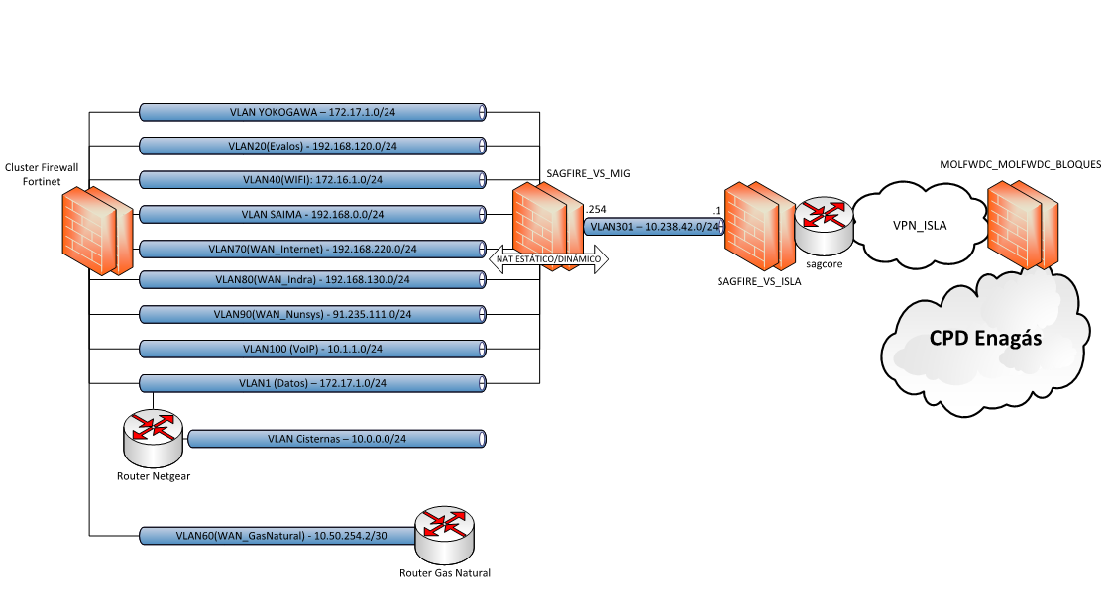

Figura 8 Esquema contexto migración

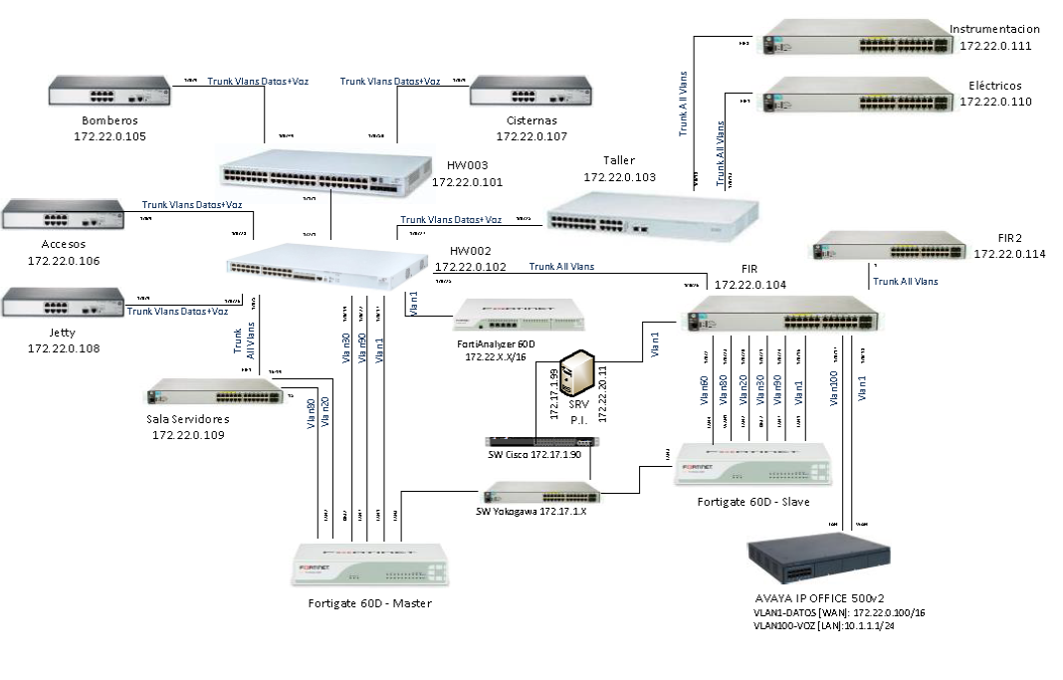

Figura 9 Esquema red actual en proceso de migración

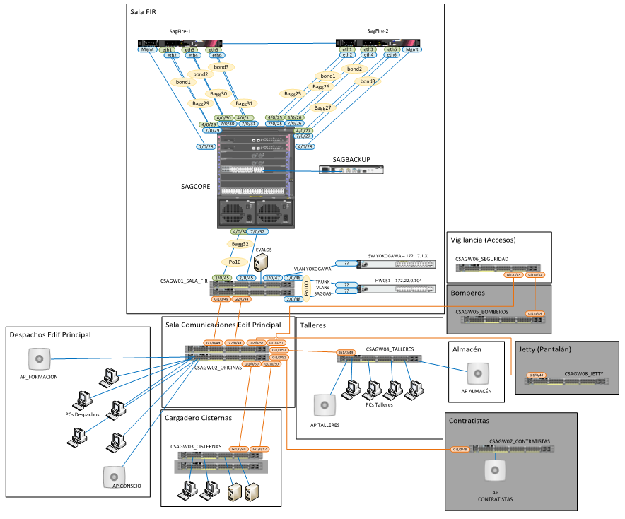

Figura 10 Esquema físico Futuro

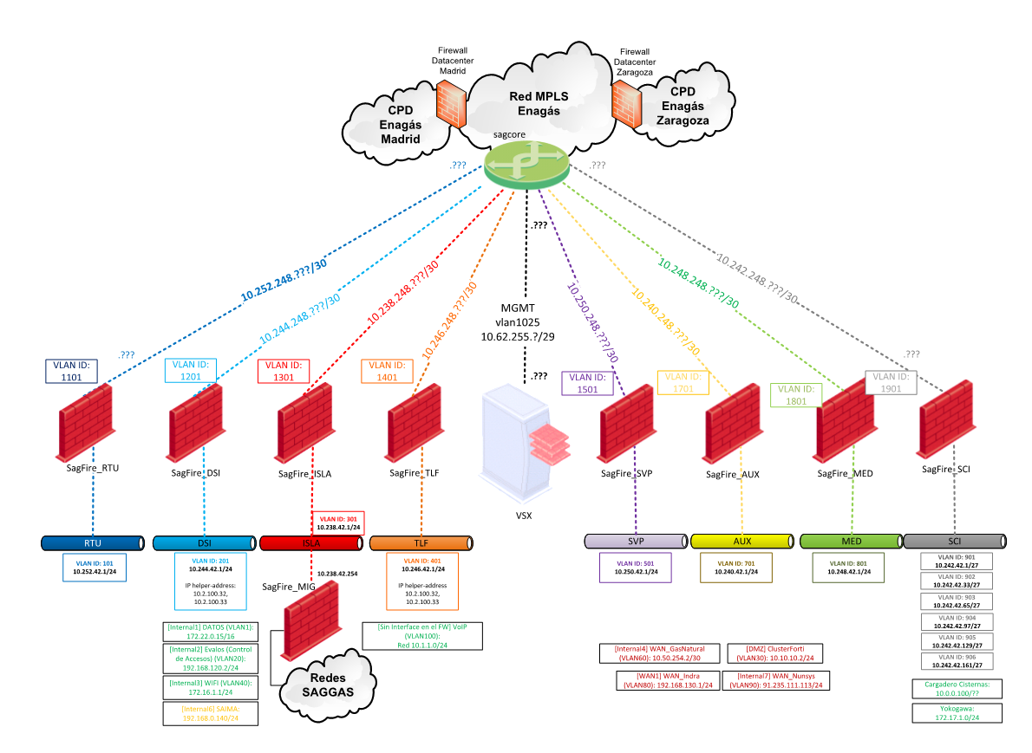

Figura 11 Esquema lógico Futuro

TIPO DE EQUIPAMIENTO HARDWARE PARA SISTEMA INFORMATICO GESTIÓN CORPORATIVA

|  |  |  |
| --- | --- | --- |
| **DESCRIPCIÓN** | **FABRICANTE** | **MODELO** |
| Servidor | IBM | System x3650 M4 -[7915E7G] |
| Cabina de almacenamiento | IBM | Storwize v3700 |
| Equipo portátil | Microsoft | Surface Pro 4 |
| Equipo portátil | Microsoft | Surface Pro 3 |
| Equipo portátil | HP | HP ProBook 4540s |
| Equipo sobremesa | Lenovo | 3245B6G |
| Equipo sobremesa | Lenovo | MT-M 10A8-S0HG00 |

EQUIPAMIENTO SOFTWARE PARA SISTEMA INFORMÁTICO DE GESTIÓN CORPORATIVA

| **Título** | **Versión** | **Productor** |
| --- | --- | --- |
| 7-Zip 9.12 beta | — | — |
| 7-Zip 9.20 | — | — |
| 7-Zip 9.20 (x64 edition) | 9.20.00.0 | Igor Pavlov |
| 7-Zip 9.38 (x64 edition) | 9.38.00.0 | Igor Pavlov |
| 7-Zip 16.02 | 16.02 | Igor Pavlov |
| 7-Zip 18.01 (x64) | 18.01 | Igor Pavlov |
| 3500 Rack Configuration Software | 5.1 SP1 | Bently Nevada Inc. |
| 3500/22M Firmware Update 1.75 | 1.75 | Bently Nevada Inc. |
| 3500/25 Keyhpasor Firmware Update 3.50 | — | — |
| Actualización de NVIDIA 10.4.0 | 10.4.0 | NVIDIA Corporation |
| Adobe Acrobat Reader DC - Español | 18.009.20050 | Adobe Systems Incorporated |
| Adobe Acrobat X Pro - Italiano, Español, Nederlands, Português | 10.0.0 | Adobe Systems |
| Adobe Acrobat XI Pro | 11.0.07 | Adobe Systems |
| Adobe AIR | 3.4.0.2710 | Adobe Systems Incorporated |
| Adobe Flash Player 10 ActiveX | 10.0.32.18 | Adobe Systems, Inc. |
| Adobe Flash Player 10 Plugin | 10.0.32.18 | Adobe Systems, Inc. |
| Adobe Flash Player 11 ActiveX | 11.0.1.152 | Adobe Systems Incorporated |
| Adobe Flash Player 12 ActiveX | 12.0.0.38 | Adobe Systems Incorporated |
| Adobe Flash Player 14 Plugin | 14.0.0.145 | Adobe Systems Incorporated |
| Adobe Flash Player 17 ActiveX | 17.0.0.169 | Adobe Systems Incorporated |
| Adobe Flash Player 18 ActiveX | 18.0.0.261 | Adobe Systems Incorporated |
| Adobe Flash Player 21 ActiveX | 21.0.0.242 | Adobe Systems Incorporated |
| Adobe Flash Player 25 ActiveX | 25.0.0.171 | Adobe Systems Incorporated |
| Adobe Flash Player 30 ActiveX | 30.0.0.113 | Adobe Systems Incorporated |
| Adobe Flash Player 30 PPAPI | 30.0.0.113 | Adobe Systems Incorporated |
| Adobe Reader XI - Español | 11.0.00 | Adobe Systems Incorporated |
| Adobe Reader XI (11.0.10) - Español | 11.0.10 | Adobe Systems Incorporated |
| Adobe Reader XI (11.0.20) - Español | 11.0.20 | Adobe Systems Incorporated |
| Adobe Reader XI (11.0.23) - Español | 11.0.23 | Adobe Systems Incorporated |
| AMD Catalyst Install Manager | 8.0.881.0 | Advanced Micro Devices, Inc. |
| AMS Machinery Manager | v5.61 | Computational Systems, Inc. |
| Aplicación de escritorio de Autodesk | 7.0.9.191 | Autodesk |
| APLICACION POC INT ETOKEN | 2.0.0 | ENAGAS |
| APLICACION POC MIG ETOKEN | 1.0.0 | ENAGAS |
| APLICACION POC PRO ETOKEN | 2.1.0 | ENAGAS |
| APLICACION POC PRO OCTUBRE ETOKEN | 3.0.4 | ENAGAS |
| Apple Application Support (32 bits) | 6.2.1 | Apple Inc. |
| Apple Application Support (64 bits) | 6.2.1 | Apple Inc. |
| Apple Mobile Device Support | 11.0.2.4 | Apple Inc. |
| Apple Software Update | 2.5.0.1 | Apple Inc. |
| Archivos auxiliares de instalación de Microsoft SQL Server 2008 | 10.3.5500.0 | Microsoft Corporation |
| Asistente para actualización a Windows 10 | 1.4.9200.17387 | Microsoft Corporation |
| Asterisk Key 10.0 | — | — |
| Autodesk AutoCAD LT 2019 - Español (Spanish) | 23.0.46.0 | Autodesk |
| Autodesk Content Service | 3.0.84.0 | Autodesk |
| Autodesk Design Review 2013 | 13.0.0.82 | Autodesk, Inc. |
| Autodesk DWG TrueView 2016 - English | 20.1.49.0 | Autodesk |
| Autodesk DWG TrueView 2017 - English | 21.0.52.0 | Autodesk |
| Autodesk DWG TrueView 2018 - English | 22.0.50.0 | Autodesk |
| Autodesk License Service (x64) - 7.1.4 | 7.1.4.0 | Autodesk |
| Autodesk Material Library 2013 | 3.0.13 | Autodesk |
| Autodesk Material Library 2019 | 17.11.3.0 | Autodesk |
| Autodesk Material Library Base Resolution Image Library 2013 | 3.0.13 | Autodesk |
| Autodesk Material Library Base Resolution Image Library 2019 | 17.11.3.0 | Autodesk |
| Autodesk Sync | 3.5.24.0 | Autodesk, Inc. |
| AutoFirma | 1.5.0 | Gobierno de España |
| Avaya Scopia® Desktop Client | — | Avaya, Inc. |
| Avaya Web Collaboration Plugin | 1.0.0.5 | Avaya |
| Avira | 1.2.103.26908 | Avira Operations GmbH & Co. KG |
| Avira Antivirus | 15.0.34.17 | Avira Operations GmbH & Co. KG |
| BMC BladeLogic Server Automation RSCD Agent | 8.7.00.239 | BMC Software |
| BMC Software Tools | — | BMC Software |
| Bonjour | 3.1.0.1 | Apple Inc. |
| Brother P-touch Address Book 1.0 | 1.0 | Brother Industries, Ltd. |
| Brother P-touch Editor 4.2 | 4.2 | Brother Industries, Ltd. |
| Brother P-touch Editor 5.1 | 5.1.0610 | Brother Industries, Ltd. |
| Brother QL-Series User's Guide | 1.0.001 | Brother Industries, Ltd. |
| BurnAware Free 8.4 | — | Burnaware |
| Cardream3 | 12.30.14 | Cardream3 Card Printing Software |
| Cardream3 Demo | 12.30.0 | Cardream3 Card Printing Software |
| CCleaner | 5.21 | Piriform |
| Centro de Mouse y Teclado de Microsoft | 2.7.133.0 | Microsoft Corporation |
| Cisco AnyConnect Secure Mobility Client | 3.1.00495 | Cisco Systems, Inc. |
| Cisco AnyConnect VPN Client | 2.4.1012 | Cisco Systems, Inc. |
| Cisco WebEx Meetings | — | Cisco WebEx LLC |
| Citrix Online Launcher | 1.0.408 | Citrix |
| Classic Shell | 4.0.5 | IvoSoft |
| Cliente Citrix Presentation Server - Web solamente | 10.200.2650 | Citrix Systems, Inc. |
| CMX | 2.11.2 | Beamex Oy Ab |
| CMX Database Connection | 2.11 | Beamex Oy Ab |
| Cole2k Media - Codec Pack (Standard) 8.0.2 | 8.0.2 | Cole2k Media |
| Configurador AEAT | 2.8 | AEAT |
| Configurador_FNMT | 3.6 | FNMT-RCM |
| Connect2 | 4.2.0.3818 | Lenovo |
| Control ActiveX de Windows Live Mesh para conexiones remotas | 15.4.5722.2 | Microsoft Corporation |
| Conversor de Libros de IVA | 0.3.8 | AEAT |
| Corel Burn.Now Lenovo Edition | 4.5.0 | Corel Corporation |
| Create Recovery Media | 1.20.0.00 | Lenovo Group Limited |
| CSI USB Driver | 1.0.1.4 | Emerson Process Management |
| CyberLink Media Suite 10 | 10.0.1.2106 | CyberLink Corp. |
| CyberLink PhotoDirector | 2.0.1.3109 | CyberLink Corp. |
| CyberLink Power2Go 8 | 8.0.3.3207 | CyberLink Corp. |
| CyberLink PowerDirector 10 | 10.0.1.2006 | CyberLink Corp. |
| CyberLink PowerDVD | 10.0.6.4330 | CyberLink Corp. |
| CyberLink YouCam | 4.1.1.3231 | CyberLink Corp. |
| Depósito digital 2013 | 5.0.0 | Colegio de Registradores |
| Depósito digital 2014 | 5.0.2 | Colegio de Registradores |
| Depósito digital 2015 | 6.1.0 | Colegio de Registradores |
| Depósito digital 2016 | 8.4.0 | Colegio de Registradores |
| Depósito digital 2017 | 9.4.0 | Colegio de Registradores |
| Design & Print | 1.0.0 | Avery Products Corp. |
| Device Access Manager for HP ProtectTools | 7.1.0.3 | Hewlett-Packard Company |
| DHTML Editing Component | 6.02.0001 | Microsoft Corporation |
| Directivas de Microsoft SQL Server 2014 | 12.0.2000.8 | Microsoft Corporation |
| DisplayLink Core Software | 7.5.54609.0 | DisplayLink Corp. |
| Dräger CC-Vision E-Cal | — | — |
| Dropbox | 51.4.66 | Dropbox, Inc. |
| DWG TrueView 2012 | 18.2.51.0 | Autodesk |
| eMule | — | — |
| Energy Star | 1.0.8 | Hewlett-Packard |
| Engineering Client Viewer 7.0 | — | SAP AG |
| Escritorio movistar | — | Escritorio movistar |
| eSignaDesktop | 1.0.7 | Indenova S.L. |
| eToken PKI Client 5.1 SP1 | 5.1.66.0 | Aladdin Knowledge Systems Ltd. |
| Evernote v. 4.5.7 | 4.5.7.7146 | Evernote Corp. |
| Extended Asian Language font pack for Adobe Acrobat Reader DC | 15.007.20033 | Adobe Systems Incorporated |
| Face Recognition for HP ProtectTools | 7.2.0.4542 | Hewlett-Packard Company |
| Factura Telematica 8.2.30 | — | — |
| FARO LS 1.1.505.3 (64bit) | 5.5.3.16 | FARO Scanner Production |
| FARO LS 1.1.600.2 (64bit) | 6.0.2.23 | FARO Scanner Production |
| FileZilla Client 3.26.2 | 3.26.2 | Tim Kosse |
| FlukeView Forms Basic | — | — |
| FlukeView Power Quality Analyzer 2.0 English | — | — |
| FlukeView Power Quality Analyzer 3 | — | — |
| FlukeViewFormsVcRedist | 9.0.21022 | Fluke |
| Folder Size (64-bit) | 2.6 | Brio |
| FortiClient | 4.3.5.0472 | Fortinet Inc |
| FortiExplorer v2.3.1052 | 2.3.1052 | Fortinet Inc. |
| Fortinet SSO Collector Agent v4.3.0161 | 4.3.0161 | Fortinet |
| Foxit Reader | 5.3.1.606 | Foxit Corporation |
| Galaxy Network Manager | — | — |
| GANES 3.1.2 3.1.2 | 3.1.2 | Correos |
| Garmin BaseCamp | 4.5.2 | Garmin Ltd or its subsidiaries |
| Garmin Communicator Plugin | 4.2.0 | Garmin Ltd or its subsidiaries |
| Garmin Communicator Plugin x64 | 4.2.0 | Garmin Ltd or its subsidiaries |
| Garmin Express | 5.3.1.0 | Garmin Ltd or its subsidiaries |
| Garmin USB Drivers | 2.3.0.0 | Garmin Ltd or its subsidiaries |
| Gestor de energía | 3.40.0001 | Lenovo Group Limited |
| GNU Privacy Guard | 2.2.4 | The GnuPG Project |
| Gold First ActiveBook | — | Pearson Education |
| Google Chrome | 63.0.3239.132 | Google Inc. |
| Google Earth | 4.3.7204.836 | Google |
| Google Toolbar for Internet Explorer | 7.5.8231.2252 | Google Inc. |
| GoTo Opener | 1.0.473 | LogMeIn, Inc. |
| GoToMeeting 7.31.0.6291 | 7.31.0.6291 | CitrixOnline |
| GoToMeeting 8.25.0.8625 | 8.25.0.8625 | LogMeIn, Inc. |
| GoToMeeting 8.29.1.8953 | 8.29.1.8953 | LogMeIn, Inc. |
| Gpg4win (2.2.5) | 2.2.5 | The Gpg4win Project |
| Gpg4win (3.0.3) | 3.0.3 | The Gpg4win Project |
| Gpg4win (3.1.1) | 3.1.1 | The Gpg4win Project |
| HART Communication FDT 1.2 DTM (V1.0.52) | 1.0.52.0 | CodeWrights |
| Hofmann 9.9 | 9.9 | Hofmann |
| HP 3D DriveGuard | 5.1.5.1 | Hewlett-Packard Company |
| HP Documentation | 1.2.0.0 | Hewlett-Packard |
| HP Dropbox Plugin | 36.0.41.58587 | HP |
| HP ESU for Microsoft Windows 8 | 1.2.2 | Hewlett-Packard Company |
| HP Google Drive Plugin | 36.0.41.58587 | HP |
| HP HD Webcam Driver | 6.0.1112.2_WHQL | Sonix |
| HP Hotkey Support | 5.0.21.1 | Hewlett-Packard Company |
| HP LaserJet MFP M129-M134 Software básico del dispositivo | 40.1.1047.62877 | HP Inc. |
| HP LaserJet Pro M11-M13 Series | — | — |
| HP LaserJet Professional M1130-M1210 MFP Series | — | — |
| HP LaserJet Professional M1210 MFP Series Fax Installer | 1.1.0 | HP |
| HP LaserJet Professional P1100-P1560-P1600 Series | — | — |
| HP OfficeJet Pro 6970 Software básico del dispositivo | 39.2.1964.60632 | HP Inc. |
| HP ProtectTools Security Manager | 8.0.3.1345 | Hewlett-Packard Company |
| HP Registration Service | 1.0.5976.4186 | Hewlett-Packard |
| HP SoftPaq Download Manager | 3.4.6.0 | Hewlett-Packard Company |
| HP Software Framework | 4.6.10.1 | Hewlett-Packard Company |
| HP Software Setup | 8.5.4.1 | Hewlett-Packard Company |
| HP Support Assistant | 8.2.8.25 | HP |
| HP Support Solutions Framework | 12.4.18.7 | HP |
| HP System Default Settings | 1.3.2 | Hewlett-Packard Company |
| HP Wireless Button Driver | 1.1.2.1 | Hewlett-Packard Company |
| I.R.I.S. OCR | 12.3.7.0 | HP |
| iCloud | 7.2.0.67 | Apple Inc. |
| ICS Generic HART Release 4 FDT 1.2 DTM | 4.0.3 | ICS GmbH, Ettlingen |
| iDisplay 3.0.12 | 3.0.12 | SHAPE |
| IDT Audio | 1.0.6428.0 | IDT |
| IMCCalcularInstaller version 4.7.0 | 4.7.0 | IMCCalcular |
| Inc@Web - Visualizador de Documentos | — | — |
| Inc@Web - Visualizador de Documentos (C:\Program Files (x86)\Inc@Web\Visualizador de Documentos\) | — | — |
| incaWeb - Visualizador de Documentos | — | — |
| incaWeb - Visualizador de Documentos (C:\Program Files (x86)\incaWeb\Visualizador de Documentos\) | — | — |
| incaWeb - Visualizador de Documentos (C:\Program Files (x86)\incaWeb\Visualizador de Documentos\) #3 | — | — |
| incaWeb - Visualizador de Documentos (C:\Program Files (x86)\incaWeb\Visualizador de Documentos\) #4 | — | — |
| incaWeb - Visualizador de Documentos (C:\Program Files (x86)\incaWeb\Visualizador de Documentos\) #5 | — | — |
| incaWeb - Visualizador de Documentos (C:\Program Files (x86)\incaWeb\Visualizador de Documentos\) #6 | — | — |
| Informativas 11.00 | 12.02 | AEAT |
| Instalación de DivX | 2.7.0.31 | DivX, LLC |
| Instalación de Microsoft SQL Server 2014 (español) | 12.0.2000.8 | Microsoft Corporation |
| Intel(R) Control Center | 1.2.1.1007 | Intel Corporation |
| Intel(R) Display Audio Driver | 6.14.00.3097 | Intel Corporation |
| Intel(R) Management Engine Components | 8.1.0.1281 | Intel Corporation |
| Intel(R) Network Connections 22.7.18.0 | 22.7.18.0 | Intel |
| Intel(R) Network Connections Drivers | 14.5 | Intel |
| Intel(R) Processor Graphics | 10.18.15.4256 | Intel Corporation |
| Intel(R) Rapid Storage Technology | 11.6.5.1006 | Intel Corporation |
| Intel(R) USB 3.0 eXtensible Host Controller Driver | 2.5.0.19 | Intel Corporation |
| Intergraph SmartPlant License Manager | 12.00.87.00 | Intergraph |
| Intergraph SmartPlant Review | 11.1.0.114 | Intergraph |
| Invoice Capture Center 5.2 SR01 SP5 | 5.2.116 | Open Text |
| iTunes | 12.7.2.60 | Apple Inc. |
| IVA 2014 1.02 | 1.02 | AEAT |
| IVA 2015 1.00 | 1.00 | AEAT |
| IVA 2016 1.00 | 1.00 | AEAT |
| Java 7 Update 21 (64-bit) | 7.0.210 | Oracle |
| Java 7 Update 45 | 7.0.450 | Oracle |
| Java 8 Update 45 | 8.0.450 | Oracle Corporation |
| Java 8 Update 91 | 8.0.910.14 | Oracle Corporation |
| Java 8 Update 101 | 8.0.1010.13 | Oracle Corporation |
| Java 8 Update 111 | 8.0.1110.14 | Oracle Corporation |
| Java 8 Update 121 | 8.0.1210.13 | Oracle Corporation |
| Java 8 Update 131 | 8.0.1310.11 | Oracle Corporation |
| Java 8 Update 141 (64-bit) | 8.0.1410.15 | Oracle Corporation |
| Java 8 Update 144 | 8.0.1440.1 | Oracle Corporation |
| Java 8 Update 151 | 8.0.1510.12 | Oracle Corporation |
| Java 8 Update 161 | 8.0.1610.12 | Oracle Corporation |
| Java 8 Update 171 | 8.0.1710.11 | Oracle Corporation |
| Java(TM) 6 Update 20 | 6.0.200 | Sun Microsystems, Inc. |
| Java(TM) 6 Update 24 | 6.0.240 | Oracle |
| Java(TM) 6 Update 26 | 6.0.260 | Oracle |
| Java(TM) 7 Update 5 | 7.0.50 | Oracle |
| JMicron Flash Media Controller Driver | 1.0.72.4 | JMicron Technology Corp. |
| Juniper Networks, Inc. Setup Client 64-bit Activex Control | 2.1.1.1 | Juniper Networks, Inc. |
| KeePass Password Safe 1.28 | 1.28 | Dominik Reichl |
| KeePass Password Safe 2.30 | 2.30 | Dominik Reichl |
| KeePass Password Safe 2.35 | 2.35 | Dominik Reichl |
| KeePass Password Safe 2.38 | 2.38 | Dominik Reichl |
| KM-2550TWAIN | — | — |
| Kyocera Address Book | 1.30 | KYOCERA MITA Corporation |
| Kyocera Address Editor | 1.50 | KyoceraMita |
| Kyocera Product Library | 2.0.0713 | KYOCERA MITA Corporation |
| Kyocera Scanner File Utility | — | — |
| LabelMark 5 | 5.11.0.31 | Brady Corporation |
| LabelMark 5 Add-Ins | 5.13.0.7 | Brady Corporation |
| LabelMark Printer Management Add-In | 5.11.0.31 | Brady Corporation |
| LBAI | 1.0.0.8 | Lenovo Group Limited |
| Legalia 2 | 1.4.0 | Sip 2000 Sistemas |
| Lenovo Mouse Suite | 6.42 | Lenovo |
| Lenovo Preferred Pro USB Fingerprint Keyboard Hotkey Driver | 3.4.0.1 | Lenovo |
| Lenovo Service Bridge | 1.6.6.0 | Lenovo |
| Lenovo Solution Center | 3.4.003.013 | Lenovo |
| Lenovo System Update | 5.07.0070 | Lenovo |
| Lenovo Ultraslim Plus Wireless Keyboard & Mouse | 1.8 | Lenovo |
| Lenovo USB Graphics | 7.5.54614.0 | Lenovo |
| Lenovo USB3.0 to DVI VGA Monitor Adapter | 1.07.17 | Lenovo |
| Lernout & Hauspie TruVoice American English TTS Engine | — | — |
| LiveUpdate 3.3 (Symantec Corporation) | 3.3.100.15 | Symantec Corporation |
| LM129 | 0.00.0005 | HP |
| Lotus Notes 8.5.2 | 8.52.10222 | IBM |
| Lotus Notes 8.5.2 es | 8.52.10200 | IBM |
| Malwarebytes Anti-Malware versión 2.2.1.1043 | 2.2.1.1043 | Malwarebytes |
| MarkWare | 3.8.0 | Brady Corporation |
| MatrikonOPC Server for System1 | — | — |
| Matrox Graphics Software (remove only) | — | — |
| McAfee Agent | 4.8.0.1938 | McAfee, Inc. |
| McAfee DLP Endpoint | 10.0.260.42 | McAfee, Inc. |
| McAfee ePolicy Orchestrator | 5.3.2 | McAfee, Inc. |
| McAfee Product Improvement Program | 1.6.0.623 | McAfee, Inc. |
| McAfee VirusScan Enterprise | 8.8.09000 | McAfee, Inc. |
| MetaFrame Presentation Server Web Client for Win32 | — | — |
| Microsoft .NET Framework 4 Client Profile | 4.0.30319 | Microsoft Corporation |
| Microsoft .NET Framework 4 Extended | 4.0.30319 | Microsoft Corporation |
| Microsoft .NET Framework 4 Multi-Targeting Pack | 4.0.30319 | Microsoft Corporation |
| Microsoft .NET Framework 4.5.2 | 4.5.51209 | Microsoft Corporation |
| Microsoft .NET Framework 4.5.2 (čeština) | 4.5.51209 | Microsoft Corporation |
| Microsoft .NET Framework 4.5.2 (Deutsch) | 4.5.51209 | Microsoft Corporation |
| Microsoft .NET Framework 4.5.2 (español) | 4.5.51209 | Microsoft Corporation |
| Microsoft .NET Framework 4.5.2 (Français) | 4.5.51209 | Microsoft Corporation |
| Microsoft .NET Framework 4.5.2 (Italiano) | 4.5.51209 | Microsoft Corporation |
| Microsoft .NET Framework 4.5.2 (Polski) | 4.5.51209 | Microsoft Corporation |
| Microsoft .NET Framework 4.5.2 (Português do Brasil) | 4.5.51209 | Microsoft Corporation |
| Microsoft .NET Framework 4.5.2 (Türkçe) | 4.5.51209 | Microsoft Corporation |
| Microsoft .NET Framework 4.5.2 (Русский) | 4.5.51209 | Корпорация Майкрософт |
| Microsoft .NET Framework 4.5.2 (日本語) | 4.5.51209 | Microsoft Corporation |
| Microsoft .NET Framework 4.5.2(한국어) | 4.5.51209 | Microsoft Corporation |
| Microsoft .NET Framework 4.6 Targeting Pack | 4.6.00081 | Microsoft Corporation |
| Microsoft .NET Framework 4.6.1 | 4.6.01055 | Microsoft Corporation |
| Microsoft .NET Framework 4.6.1 (español) | 4.6.01055 | Microsoft Corporation |
| Microsoft .NET Framework 4.7 | 4.7.02053 | Microsoft Corporation |
| Microsoft .NET Framework 4.7 (español) | 4.7.02053 | Microsoft Corporation |
| Microsoft Access database engine 2010 (English) | 14.0.6029.1000 | Microsoft Corporation |
| Microsoft Access database engine 2010 (Spanish) | 14.0.7015.1000 | Microsoft Corporation |
| Microsoft Access Runtime 2010 | 14.0.7015.1000 | Microsoft Corporation |
| Microsoft Access Runtime 2013 | 15.0.4569.1506 | Microsoft Corporation |
| Microsoft ASP.NET MVC 2 | 2.0.60926.0 | Microsoft Corporation |
| Microsoft Connectivity Analyzer | 15.1.106.1 | Microsoft Corporation |
| Microsoft Help Viewer 1.1 | 1.1.40219 | Microsoft Corporation |
| Microsoft Help Viewer 1.1 Language Pack - ESN | 1.1.40219 | Microsoft Corporation |
| Microsoft ODBC Driver 11 for SQL Server | 12.0.2000.8 | Microsoft Corporation |
| Microsoft Office | 14.0.6120.5004 | Microsoft Corporation |
| Microsoft Office 365 - es-es | 16.0.8730.2165 | Microsoft Corporation |
| Microsoft Office 2003 Primary Interop Assemblies | 11.0.6553.0 | Microsoft Corporation |
| Microsoft Office Hogar y Empresas 2013 - es-es | 15.0.5031.1000 | Microsoft Corporation |
| Microsoft Office Hogar y Pequeña Empresa 2010 | 14.0.7015.1000 | Microsoft Corporation |
| Microsoft Office Outlook Connector | 14.0.6123.5001 | Microsoft Corporation |
| Microsoft Office Profesional 2013 - es-es | 15.0.5015.1000 | Microsoft Corporation |
| Microsoft Office Professional 2010 | 14.0.7015.1000 | Microsoft Corporation |
| Microsoft OneDrive | 17.3.6743.1212 | Microsoft Corporation |
| Microsoft redistributable runtime DLLs VS2005 SP1(x86) | 8.0.50727.4053 | SAP |
| Microsoft redistributable runtime DLLs VS2008 SP1(x86) | 9.0 | SAP AG |
| Microsoft redistributable runtime DLLs VS2010 SP1 (x86) | 10.0.40219.1 | SAP |
| Microsoft Report Viewer 2012 Runtime | 11.0.2100.60 | Microsoft Corporation |
| Microsoft Report Viewer 2014 Runtime | 12.0.2000.8 | Microsoft Corporation |
| Microsoft Report Viewer Redistributable 2008 SP1 | 9.0.30729 | Microsoft Corporation |
| Microsoft ReportViewer 2010 Redistributable | 10.0.30319 | Microsoft Corporation |
| Microsoft ReportViewer 2010 SP1 Redistributable | 10.0.40219 | Microsoft Corporation |
| Microsoft Silverlight | 5.1.50907.0 | Microsoft Corporation |
| Microsoft SkyDrive | 16.4.6012.0828 | Microsoft Corporation |
| Microsoft SQL Server 2005 Backward compatibility | 8.05.2309 | Microsoft Corporation |
| Microsoft SQL Server 2008 R2 (64-bit) | — | Microsoft Corporation |
| Microsoft SQL Server 2008 R2 Management Objects | 10.51.2500.0 | Microsoft Corporation |
| Microsoft SQL Server 2008 R2 Native Client | 10.52.4000.0 | Microsoft Corporation |
| Microsoft SQL Server 2008 R2 Policies | 10.50.1600.1 | Microsoft Corporation |
| Microsoft SQL Server 2008 R2 Setup (English) | 10.52.4000.0 | Microsoft Corporation |
| Microsoft SQL Server 2008 Setup Support Files | 10.1.2731.0 | Microsoft Corporation |
| Microsoft SQL Server 2012 (64-bit) | — | Microsoft Corporation |
| Microsoft SQL Server 2012 Management Objects | 11.0.2100.60 | Microsoft Corporation |
| Microsoft SQL Server 2012 Management Objects (x64) | 11.0.2100.60 | Microsoft Corporation |
| Microsoft SQL Server 2012 Native Client | 11.0.2100.60 | Microsoft Corporation |
| Microsoft SQL Server 2012 Setup (English) | 11.1.3128.0 | Microsoft Corporation |
| Microsoft SQL Server 2012 Transact-SQL Compiler Service | 11.1.3128.0 | Microsoft Corporation |
| Microsoft SQL Server 2012 Transact-SQL ScriptDom | 11.1.3000.0 | Microsoft Corporation |
| Microsoft SQL Server 2014 | — | Microsoft Corporation |
| Microsoft SQL Server 2014 Setup (English) | 12.2.5000.0 | Microsoft Corporation |
| Microsoft SQL Server 2014 Transact-SQL Compiler Service | 12.0.2000.8 | Microsoft Corporation |
| Microsoft SQL Server 2014 Transact-SQL ScriptDom | 12.0.2000.8 | Microsoft Corporation |
| Microsoft SQL Server Browser | 10.51.2500.0 | Microsoft Corporation |
| Microsoft SQL Server Compact 3.5 SP2 ENU | 3.5.8080.0 | Microsoft Corporation |
| Microsoft SQL Server Compact 3.5 SP2 Query Tools ENU | 3.5.8080.0 | Microsoft Corporation |
| Microsoft SQL Server Native Client | 9.00.3042.00 | Microsoft Corporation |
| Microsoft SQL Server Setup Support Files (English) | 9.00.3042.00 | Microsoft Corporation |
| Microsoft SQL Server System CLR Types | 10.51.2500.0 | Microsoft Corporation |
| Microsoft SQL Server VSS Writer | 9.00.3042.00 | Microsoft Corporation |
| Microsoft System CLR Types for SQL Server 2012 | 11.0.2100.60 | Microsoft Corporation |
| Microsoft System CLR Types for SQL Server 2012 (x64) | 11.1.3000.0 | Microsoft Corporation |
| Microsoft System CLR Types para SQL Server 2014 | 12.0.2000.8 | Microsoft Corporation |
| Microsoft Tool Web Package : EXCTRLST.EXE | 1.00.0.1 | Microsoft Corporation |
| Microsoft Visual C++ 2005 Redistributable | 8.0.61001 | Microsoft Corporation |
| Microsoft Visual C++ 2005 Redistributable (x64) | 8.0.56336 | Microsoft Corporation |
| Microsoft Visual C++ 2008 Redistributable - x64 9.0.21022 | 9.0.21022 | Microsoft Corporation |
| Microsoft Visual C++ 2008 Redistributable - x64 9.0.30729 | 9.0.30729 | Microsoft Corporation |
| Microsoft Visual C++ 2008 Redistributable - x64 9.0.30729.17 | 9.0.30729 | Microsoft Corporation |
| Microsoft Visual C++ 2008 Redistributable - x64 9.0.30729.4148 | 9.0.30729.4148 | Microsoft Corporation |
| Microsoft Visual C++ 2008 Redistributable - x64 9.0.30729.6161 | 9.0.30729.6161 | Microsoft Corporation |
| Microsoft Visual C++ 2008 Redistributable - x86 9.0.21022 | 9.0.21022 | Microsoft Corporation |
| Microsoft Visual C++ 2008 Redistributable - x86 9.0.30729 | 9.0.30729 | Microsoft Corporation |
| Microsoft Visual C++ 2008 Redistributable - x86 9.0.30729.17 | 9.0.30729 | Microsoft Corporation |
| Microsoft Visual C++ 2008 Redistributable - x86 9.0.30729.4148 | 9.0.30729.4148 | Microsoft Corporation |
| Microsoft Visual C++ 2008 Redistributable - x86 9.0.30729.4974 | 9.0.30729.4974 | Microsoft Corporation |
| Microsoft Visual C++ 2008 Redistributable - x86 9.0.30729.6161 | 9.0.30729.6161 | Microsoft Corporation |
| Microsoft Visual C++ 2010 x64 Redistributable - 10.0.40219 | 10.0.40219 | Microsoft Corporation |
| Microsoft Visual C++ 2010 x86 Redistributable - 10.0.40219 | 10.0.40219 | Microsoft Corporation |
| Microsoft Visual C++ 2010 x86 Runtime - 10.0.40219 | 10.0.40219 | Microsoft Corporation |
| Microsoft Visual C++ 2012 Redistributable (x64) - 11.0.60610 | 11.0.60610.1 | Microsoft Corporation |
| Microsoft Visual C++ 2012 Redistributable (x64) - 11.0.61030 | 11.0.61030.0 | Microsoft Corporation |
| Microsoft Visual C++ 2012 Redistributable (x86) - 11.0.61030 | 11.0.61030.0 | Microsoft Corporation |
| Microsoft Visual C++ 2013 Redistributable (x64) - 12.0.21005 | 12.0.21005.1 | Microsoft Corporation |
| Microsoft Visual C++ 2013 Redistributable (x64) - 12.0.30501 | 12.0.30501.0 | Microsoft Corporation |
| Microsoft Visual C++ 2013 Redistributable (x86) - 12.0.21005 | 12.0.21005.1 | Microsoft Corporation |
| Microsoft Visual C++ 2013 Redistributable (x86) - 12.0.30501 | 12.0.30501.0 | Microsoft Corporation |
| Microsoft Visual C++ 2015 Redistributable (x64) - 14.0.23026 | 14.0.23026.0 | Microsoft Corporation |
| Microsoft Visual C++ 2015 Redistributable (x64) - 14.0.23918 | 14.0.23918.0 | Microsoft Corporation |
| Microsoft Visual C++ 2015 Redistributable (x64) - 14.0.24212 | 14.0.24212.0 | Microsoft Corporation |
| Microsoft Visual C++ 2015 Redistributable (x86) - 14.0.23026 | 14.0.23026.0 | Microsoft Corporation |
| Microsoft Visual C++ 2015 Redistributable (x86) - 14.0.23918 | 14.0.23918.0 | Microsoft Corporation |
| Microsoft Visual C++ 2015 Redistributable (x86) - 14.0.24212 | 14.0.24212.0 | Microsoft Corporation |
| Microsoft Visual C++ 2017 Redistributable (x64) - 14.12.25810 | 14.12.25810.0 | Microsoft Corporation |
| Microsoft Visual C++ 2017 Redistributable (x86) - 14.12.25810 | 14.12.25810.0 | Microsoft Corporation |
| Microsoft Visual J# 2.0 Redistributable Package - SE (x64) | 2.0.50728 | Microsoft Corporation |
| Microsoft Visual Studio 2010 Shell (Isolated) - ENU | 10.0.40219 | Microsoft Corporation |
| Microsoft Visual Studio 2010 Shell (Isolated) - ESN | 10.0.40219 | Microsoft Corporation |
| Microsoft Visual Studio 2010 Tools for Office Runtime (x64) | 10.0.50903 | Microsoft Corporation |
| Microsoft Visual Studio 2017 | 1.5.30308.1 | Microsoft Corporation |
| Microsoft Visual Studio Tools for Applications 2.0 - ENU | 9.0.35191 | Microsoft Corporation |
| Microsoft VSS Writer for SQL Server 2012 | 11.1.3000.0 | Microsoft Corporation |
| Microsoft VSS Writer for SQL Server 2014 | 12.2.5000.0 | Microsoft Corporation |
| Microsoft VSS Writer para SQL Server 2014 | 12.0.2000.8 | Microsoft Corporation |
| Microsoft Windows 7 Professional | 6.1.7601 | Microsoft Corporation |
| Microsoft Windows 8 Pro | 6.2.9200 | Microsoft Corporation |
| Microsoft Windows 8.1 Pro | 6.3.9600 | Microsoft Corporation |
| Microsoft Windows 10 Pro | 10.0.10586 | Microsoft Corporation |
| Microsoft Windows Server 2008 R2 Standard | 6.1.7601 | Microsoft Corporation |
| Microsoft Windows Server 2012 R2 Standard | 6.3.9600 | Microsoft Corporation |
| Modbus Driver X64 | 003.016.00000 | Schneider Electric |
| MON2000 | 4.10.025 | Emerson Process Management |
| Mozilla Firefox 31.0 (x86 es-ES) | 31.0 | Mozilla |
| Mozilla Firefox 38.0.5 (x86 es-ES) | 38.0.5 | Mozilla |
| Mozilla Firefox 47.0.1 (x86 es-ES) | 47.0.1 | Mozilla |
| Mozilla Maintenance Service | 31.0 | Mozilla |
| MSALink | 2.0.6.1 | MSA |
| MSXML4.0 redistributable | 4.0.0.0 | SAP |
| MyPublicWiFi 5.1 | — | TRUE Software |
| Nike+ Connect | 6.6.34 | Nike |
| Nitro Reader 3 | 3.5.6.5 | Nitro |
| Nmap 7.60 | 7.60 | — |
| Nokia Connectivity Cable Driver | 7.1.32.69 | — |
| Notepad++ | 6.9.1 | Notepad++ Team |
| Npcap 0.93 | 0.93 | Nmap Project |
| NVIDIA Controlador de 3D Vision 347.52 | 347.52 | NVIDIA Corporation |
| NVIDIA Controlador de audio HD 1.3.33.0 | 1.3.33.0 | NVIDIA Corporation |
| NVIDIA Controlador de gráficos 347.52 | 347.52 | NVIDIA Corporation |
| Objetos de administración de Microsoft SQL Server 2008 R2 | 10.51.2500.0 | Microsoft Corporation |
| OpenSSL 1.1.0g Light (32-bit) | — | OpenSSL Win32 Installer Team |
| OSIsoft MS Runtime Redistributables | 3.1.8 | OSIsoft, LLC |
| OSIsoft MS Runtime Redistributables Addendum | 1.0.0 | OSIsoft, Inc. |
| OSIsoft MS Runtime Redistributables x64 | 3.1.1 | OSIsoft, Inc. |
| Paint.NET v3.5.8 | 3.58.0 | dotPDN LLC |
| Paquete de compatibilidad de Microsoft .NET Framework 4.6 (español) | 4.6.00081 | Microsoft Corporation |
| Paquete de compatibilidad de Microsoft .NET Framework 4.6.1 (español) | 4.6.01055 | Microsoft Corporation |
| Paquete de controladores de Windows - B&B Electronics USB-to-Serial Driver (01/18/2013 2.08.28) | 01/18/2013 2.08.28 | B&B Electronics |
| Paquete de controladores de Windows - Dynastream Innovations, Inc. ANT LibUSB Drivers (04/11/2012 1.2.40.201) | 04/11/2012 1.2.40.201 | Dynastream Innovations, Inc. |
| Paquete de controladores de Windows - GCS ltd. (KMDF_GCSPenDtuUSB) GCS-DEVICES (04/27/2012 6.1.7600.16385) | 04/27/2012 6.1.7600.16385 | GCS ltd. |
| Paquete de controladores de Windows - IDS Imaging Development Systems GmbH (ueye_boot) USB (07/31/2015 4.70.15.0) | 07/31/2015 4.70.15.0 | IDS Imaging Development Systems GmbH |
| Paquete de controladores de Windows - Intel (e1dexpress) Net (02/26/2013 12.6.47.0) | 02/26/2013 12.6.47.0 | Intel |
| Paquete de controladores de Windows - Intel (e1kexpress) Net (09/23/2009 11.2.19.0) | 09/23/2009 11.2.19.0 | Intel |
| Paquete de controladores de Windows - Intel (HECIx64) System (09/17/2009 6.0.0.1179) | 09/17/2009 6.0.0.1179 | Intel |
| Paquete de controladores de Windows - Intel (Serial) Ports (09/17/2009 6.0.0.1179) | 09/17/2009 6.0.0.1179 | Intel |
| Paquete de controladores de Windows - Intel Corporation (igfx) Display (01/29/2014 10.18.10.3412) | 01/29/2014 10.18.10.3412 | Intel Corporation |
| Paquete de controladores de Windows - Intel Corporation (igfx) Display (03/31/2010 8.15.10.2104) | 03/31/2010 8.15.10.2104 | Intel Corporation |
| Paquete de controladores de Windows - Intel hdc (06/04/2009 7.0.0.1013) | 06/04/2009 7.0.0.1013 | Intel |
| Paquete de controladores de Windows - Intel System (06/04/2009 1.0.0.0002) | 06/04/2009 1.0.0.0002 | Intel |
| Paquete de controladores de Windows - Intel System (06/04/2009 9.1.1.1013) | 06/04/2009 9.1.1.1013 | Intel |
| Paquete de controladores de Windows - Intel USB (08/20/2009 9.1.1.1020) | 08/20/2009 9.1.1.1020 | Intel |
| Paquete de controladores de Windows - Intel(R) Corporation (IntcDAud) MEDIA (02/03/2010 6.12.00.3047) | 02/03/2010 6.12.00.3047 | Intel(R) Corporation |
| Paquete de controladores de Windows - Realtek Semiconductor Corp. HD Audio Driver (11/09/2009 6.0.1.5977) | 11/09/2009 6.0.1.5977 | Realtek Semiconductor Corp. |
| Paquete de controladores de Windows - Silicon Labs Software (DSI_SiUSBXp_3_1) USB (02/06/2007 3.1) | 02/06/2007 3.1 | Silicon Labs Software |
| Paquete de idioma de Microsoft Visual Studio 2010 Tools para Office Runtime (x64) - ESN | 10.0.50903 | Microsoft Corporation |
| Paquete redistribuible del Microsoft Visor de informes 2005 | — | Microsoft Corporation |
| Patrimonio 2014 1.10 | 1.10 | AEAT |
| PCM3.0Agent | 3.0.2014.0314 | Lenovo |
| PDF Architect 2 | 2.0.24.16092 | pdfforge GmbH |
| PDF Architect 2 View Module | 2.1.6.19758 | pdfforge GmbH |
| PDF Architect 3 | 3.1.1.24880 | pdfforge GmbH |
| PDF Complete Corporate Edition | 4.1.8 | PDF Complete, Inc |
| PDFCreator | 1.7.3 | pdfforge |
| PI AF Client (x64) 2014 R2 | 2.6.1.6238 | OSIsoft, LLC |
| PI AF Client 2.x | 2.1.0 | OSIsoft, Inc. |
| PI AF Client 2015 | 2.7.0.6937 | OSIsoft, LLC |
| PI AF Client 2016 | 2.8.0.7444 | OSIsoft, LLC |
| PI AF Client 2016 R2 SP1 | 2.8.6.7801 | OSIsoft, LLC |
| PI Buffer Subsystem | 4.5.0.17 | OSIsoft, LLC |
| PI Collective Manager | 1.2.0.0 | OSIsoft, LLC |
| PI DataLink 2010 | 4.2.0.0 | OSIsoft, LLC |
| PI DataLink 2014 SP1 x64 | 5.1.1.0 | OSIsoft, LLC |
| PI DataLink 2014 SP1 x86 | 5.1.1.0 | OSIsoft, LLC |
| PI DataLink 2015 x64 | 5.2.0.0 | OSIsoft, LLC |
| PI DataLink 2015 x86 | 5.2.0.0 | OSIsoft, LLC |
| PI DataLink 2016 x64 | 5.3.0.0 | OSIsoft, LLC |
| PI DataLink 2016 x86 | 5.3.0.0 | OSIsoft, LLC |
| PI DataLink MUI (x64) 2014 | 5.1.0.67 | OSIsoft, LLC |
| PI DataLink MUI (x86) 2014 | 5.1.0.67 | OSIsoft, LLC |
| PI GenericNames DLL | 1.2.24.0 | OSIsoft, LLC |
| PI Interface Configuration Utility | 1.4.8.0 | OSIsoft, LLC |
| PI Module Database Builder | 1.3.0.0 | OSIsoft, Inc. |
| PI Network Subsystem | 3.4.405.1161 | OSIsoft, LLC |
| PI ProcessBook 3.2.0.0 | 3.2.0.0 | OSIsoft, Inc. |
| PI ProcessBook 2015 R2 | 3.6.0.82 | OSIsoft, LLC |
| PI ProcessBook MRD Add-In 3.2.0.0 | 3.2.0.0 | OSIsoft, Inc. |
| PI ProcessBook SVG Add-In 3.2.0.0 | 3.2.0.0 | OSIsoft, Inc. |
| PI Software Development Kit (PI SDK) x64 2014 | 1.4.4.484 | OSIsoft, LLC |
| PI Software Development Kit (PI SDK) x64 2014 R2 | 1.4.4.486 | OSIsoft, LLC |
| PI Software Development Kit (PI SDK) x64 2016 | 1.4.6.494 | OSIsoft, LLC |
| PI Software Development Kit (PI SDK) x86 2014 | 1.4.4.484 | OSIsoft, LLC |
| PI Software Development Kit (PI SDK) x86 2014 R2 | 1.4.4.486 | OSIsoft, LLC |
| PI Software Development Kit (PI SDK) x86 2016 | 1.4.6.494 | OSIsoft, LLC |
| PI Software Development Kit (PI-SDK) | 1.3.8.387 | OSIsoft, LLC |
| PI Spt DLL | 1.2.2.0 | OSIsoft, Inc. |
| PI System Management Tools 2010 SP1 | 3.4.0.0 | OSIsoft, LLC |
| PI TagConfigurator | 2.1.4 | OSIsoft, LLC |
| Picasa 3 | 3.9 | Google, Inc. |
| PL-2303 USB-to-Serial | — | — |
| Portel Mail | — | — |
| Power Log 2.9.2 | 2.9.2 | Fluke Electronics Corporation |
| Power Log 3.2 | 3.2 | Fluke Electronics Corporation |
| PowerDVD Create | 10.0 | CyberLink Corp. |
| ProGas 5.1 | — | — |
| ProGas v4.0 | — | — |
| Prysmitool 1.0 | — | Prysmian Cables & Systems |
| Pulse Secure Host Checker | 8.1.7.41041 | Pulse Secure, LLC |
| Pulse Secure Setup Client | 8.1.7.61533 | Pulse Secure, LLC |
| PuTTY release 0.70 (64-bit) | 0.70.0.0 | Simon Tatham |
| Ralink Bluetooth Stack64 | 9.0.725.0 | Ralink Corporation |
| Ralink RT3290 802.11bgn Wi-Fi Adapter | 5.0.45.0 | Mediatek |
| REACHit | 2.0.5.2 | Lenovo, Inc. |
| Realtek Ethernet Controller All-In-One Windows Driver | 8.2.612.2012 | Realtek |
| Realtek High Definition Audio Driver | 6.0.1.5977 | Realtek Semiconductor Corp. |
| Realtek Wireless LAN Adapter Software | 1.00.0045.0 | Realtek Semiconductor Corp. |
| Recuva | 1.53 | Piriform |
| Renta 2013 1.35 | 1.35 | AEAT |
| Renta 2014 1.20 | 1.20 | AEAT |
| Renta 2014 1.25 | 1.25 | AEAT |
| Renta 2015 1.31 | 1.31 | AEAT |
| Rescue and Recovery | 4.30.0025.00 | Lenovo Group Limited |
| Reshade 3.0 | 3.0 | Reshade |
| SafeNet Authentication Client 8.3 | 8.3.52.0 | SafeNet, Inc. |
| SafeNet iKey Driver (64-Bit) v4.1.1.7 | 4.1.1 | SafeNet, Inc. |
| SafeNet iKey Driver (64-Bit) v4.1.1.10010 | 4.1.1 | SafeNet, Inc. |
| Samsung Kies3 | 3.2.15072.2 | Samsung Electronics Co., Ltd. |
| Samsung USB Driver for Mobile Phones | 1.5.61.0 | Samsung Electronics Co., Ltd. |
| Samsung_MonSetup | 1.00.0000 | Samsung |
| SAP GUI for Windows 7.20 | 7.20 Compilation 1 | SAP |
| SAP GUI for Windows 7.40 (Patch 4) | 7.40 Compilation 1 | SAP |
| SAP GUI for Windows 7.40 (Patch 7) | 7.40 Compilation 2 | SAP SE |
| SAP JNet | — | SAP AG |
| SAPSetup Automatic Workstation Update Service | — | SAP AG |
| Scan To | 2.0.1 | HP |
| SCENE LT 5.5.3.16 x64 | 5.5.3.16 | FARO Technologies |
| SCENE LT 6.0.2.23 x64 | 6.0.2.23 | FARO Technologies |
| SDK de Microsoft .NET Framework 4.6.1 (español) | 4.6.01055 | Microsoft Corporation |
| Sentinel Runtime | 6.4.1.32979 | SafeNet Inc. |
| Sentinel System Driver Installer 7.5.9 | 7.5.9 | SafeNet, Inc. |
| SFT2826 | — | — |
| SFT2841 | 12.0.0.0 | Schneider Electric |
| SFTCommon-ICDLibrary | 1.6.1 | Schneider Electric |
| SFTCommon-SCLSchema | 1.6.37 | Schneider Electric |
| Skype for Business Web App Plug-in | 15.8.20020.351 | Microsoft Corporation |
| Skype™ 6.18 | 6.18.106 | Skype Technologies S.A. |
| Skype™ 7.8 | 7.8.102 | Skype Technologies S.A. |
| Smart Switch | 4.1.16104.4 | Samsung Electronics Co., Ltd. |
| SmartView 3.2 | 3.2 | Fluke |
| SmartView 3.14 | 3.14 | Fluke |
| Sociedades 200-2013 1.20 | 1.20 | AEAT |
| Sociedades 200-2014 1.00 | 1.00 | AEAT |
| Softonic Assistant | 0.2.2 | Softonic International S.A. |
| SolarWinds SNMP Enabler for Windows | 1.0.0.213 | SolarWinds |
| Solid PDF Creator | 9.0.2479.1 | Solid Documents |
| Songr | 2.1 | Xamasoft |
| SonicExplorer | 1.7.0010 | Elster NV/SA |
| Spotify | 1.0.74.380.g1fcff12a | Spotify AB |
| SQL Server Browser for SQL Server 2012 | 11.1.3000.0 | Microsoft Corporation |
| SQL Server Browser for SQL Server 2014 | 12.2.5000.0 | Microsoft Corporation |
| SQL Server Browser para SQL Server 2014 | 12.0.2000.8 | Microsoft Corporation |
| SQLXML 3.0 SP3 | 3.30.3457.0 | Microsoft Corporation |
| Symantec Backup Exec Remote Agent for Windows | 14.2.1180 | Symantec Corporation |
| Synaptics Pointing Device Driver | 17.0.18.8 | Synaptics Incorporated |
| System 1 | 6.89 | General Electric |
| System Update | 4.00.0046 | Lenovo |
| SystemTools DumpSec | 2.8.6 | SystemTools Software Inc |
| TeamViewer 10 | 10.0.47484 | TeamViewer |
| TeamViewer 11 | 11.0.76421 | TeamViewer |
| TEDI | 1.00.0000 | Telecable |
| TeraCopy 2.3 | — | Code Sector |
| The Dude | — | — |
| Theft Recovery for HP ProtectTools | 7.0.0.10 | Hewlett-Packard Company |
| ThinkVantage Password Manager | 4.70.22.0 | Nombre de su organización |
| Thomson Reuters Eikon Excel | 8.3.00503 | Thomson Reuters |
| Thomson Reuters Eikon Update Agent Add-On | 12.01.34 | Thomson Reuters |
| TopGuard Patrol | 2.3.3 | GCS |
| Total Network Inventory 1.6.8 (build 2800) | 1.6.8.2800 | Softinventive Lab Inc. |
| Total Network Inventory 3.0.1 (build 1675) | 3.0.1 (build 1675) | Softinventive Lab Inc. |
| TreeSize Free V2.7 | 2.7 | JAM Software |
| Ubiquiti UniFi (remove only) | — | — |
| USB Enhanced Performance Keyboard | 2.0.2.2 | Lenovo |
| Validity Fingerprint Sensor Driver | 4.4.228.0 | Validity Sensors, Inc. |
| vcredist_x86 | 1.0.0 | SAP |
| Veritas Backup Exec (TM) 16 | 16.0.1142 | Veritas Technologies LLC |
| ViewRight Web PC 3.6.0.0 | 3.6.0.0 | Verimatrix, Inc. |
| Visual Studio 2005 Tools for Office Second Edition Runtime | — | Microsoft Corporation |
| Visual Studio 2010 Prerequisites - English | 10.0.40219 | Microsoft Corporation |
| VLC media player | 2.2.1 | VideoLAN |
| VLC media player 1.1.8 | 1.1.8 | VideoLAN |
| VLC media player 2.0.1 | 2.0.1 | VideoLAN |
| VLC Setup Helper | — | Hobbyist Software |
| VMware Player | 12.5.1 | VMware, Inc. |
| VMware Tools | 9.0.15.41796 | VMware, Inc. |
| VMware vSphere Client 5.5 | 5.5.0.4330 | VMware, Inc. |
| WaveEditor | 1.0.1.4514 | CyberLink Corp. |
| WD Backup | 1.5.5953.19614 | Western Digital Technologies, Inc. |
| WD Drive Utilities | 1.3.0.18 | Western Digital Technologies, Inc. |
| WD Quick View | 2.4.10.17 | Western Digital Technologies, Inc. |
| WD Security | 1.3.1.2 | Western Digital Technologies, Inc. |
| WIBU-KEY Setup (WIBU-KEY Remove) | Version 5.20b of 2007-Apr-18 (Setup) | WIBU-SYSTEMS AG |
| Windows Driver Package - Beamex Oy Ab (MC4UsbDrv) Calibrators (10/08/2010 2.0.0.0) | 10/08/2010 2.0.0.0 | Beamex Oy Ab |
| Windows Driver Package - Beamex Oy Ab (MC6UsbDrv) Calibrators (02/09/2010 1.1.0.0) | 02/09/2010 1.1.0.0 | Beamex Oy Ab |
| Windows Driver Package - Fluke (WinUSB) Thermal Imager (08/21/2011 1.0.1) | 08/21/2011 1.0.1 | Fluke |
| Windows Driver Package - Fluke Corporation (usbser) Ports (02/22/2016 1.3.0.0) | 02/22/2016 1.3.0.0 | Fluke Corporation |
| Windows Driver Package - Garmin (grmnusb) GARMIN Devices (06/03/2009 2.3.0.0) | 06/03/2009 2.3.0.0 | Garmin |
| Windows Resource Kit Tools - LockoutStatus.exe | 1.0.0.60 | Microsoft Corporation |
| Windows Resource Kit Tools - SubInAcl.exe | 5.2.3790.1164 | Microsoft Corporation |
| Windows XP Mode | 1.3.7600.16432 | Microsoft Corporation |
| WinPcap 4.1.2 | 4.1.0.2001 | CACE Technologies |
| WinRAR 5.10 (64-bit) | 5.10.0 | win.rar GmbH |
| WinRAR 5.30 (64-bit) | 5.30.0 | win.rar GmbH |
| WinRAR 5.40 (64-bit) | 5.40.0 | win.rar GmbH |
| WinRAR 5.50 (64-bit) | 5.50.0 | win.rar GmbH |
| Wondershare Dr.Fone for Android(Build 6.2.1.49) | 6.2.1.49 | Wondershare Software Co.,Ltd. |
| XolidoSign V 2.2.1.25 | 2.2.1.25 | Xolido Systems, S.A. |
| xTalk Management Console | 6.7.0.0 | Quantum Corporation |
| Yahoo Search Set | — | Yahoo Inc. |
| Yammer Notifier - 1 | 1.0.0.513 | Microsoft Corporation |
| Zabbix Agent 3.4.3 | 3.4.3 | — |
| Zebra Setup Utilities | 1.1.9.1137 | Zebra Technologies |
| ZTE USB Driver | 1.0.1.27_TME | ZTE Corporation |

# información específica protección perimetral de la red

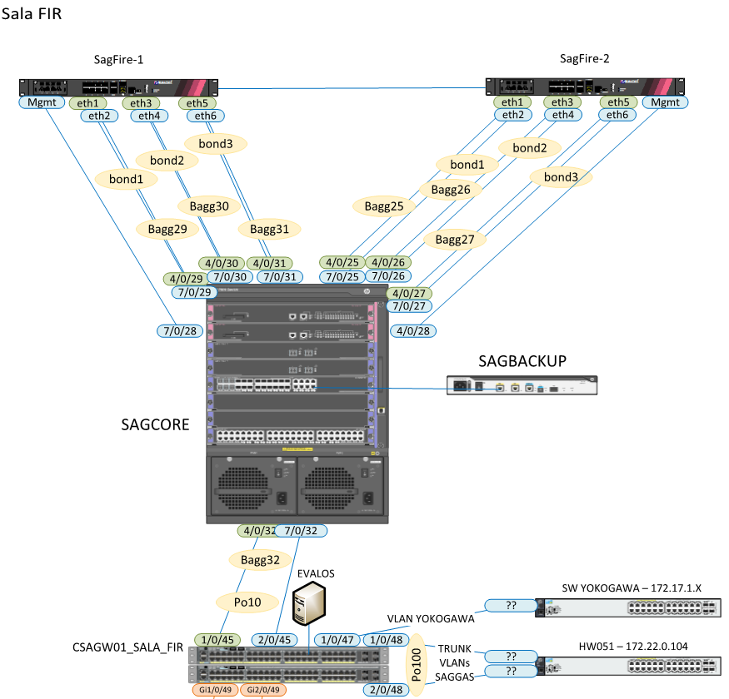

Figura 12 Esquema equipos perímetro de red

Nodo MPLS y router backup

|  |  |  |  |  |  |
| --- | --- | --- | --- | --- | --- |
| **Equipo** | **Fabricante** | **Modelo** | **IP** | **S/N** | **Firmware** |
| sagcore | HPE | HP 7506 | 10.100.100.125 | CN70H5K01K | 6709L10 - P002 |
| sagbackup | HPE | HP MSR2003 | 10.100.100.223 | CN78K1T0JL | 0306P30 |

Firewalls

|  |  |  |  |  |  |  |  |  |  |
| --- | --- | --- | --- | --- | --- | --- | --- | --- | --- |
| **Equipo** | **Fabricante** | **Modelo** | **IP** | **CI** | **S/N** | **ANS** | **Ges.Vul.** | **OS version / Firmware version** | **Parche / Subversion** |
| SAGFIRE1 | Checkpoint | 5400 | 10.62.255.202 | CI119475 | 1711BA0874 | PLATINO | true | Gaia R77.30 (64-bit) | JHA 292 |
| SAGFIRE2 | Checkpoint | 5400 | 10.62.255.203 | CI119474 | 1711BA0664 | PLATINO | true | Gaia R77.30 (64-bit) | JHA 292 |
| FG60D_HA1 | Fortinet | Fortigate 60D |  |  | FGT60D4613047065 |  |  | v5.2.13 | build762 (GA) |
| FG60D_HA2 | Fortinet | Fortigate 60D |  |  | FGT60D4613047215 |  |  | v5.2.13 | build762 (GA) |

En la figura 12 se muestra el equipamiento actual de firewall Checkpoint perimetral aunque a fecha 27/6/2018 todavía están instalados los firewall Fortinet mostrados en la figura 9.

En cuanto a seguridad de redes se cuenta con las siguientes capacidades:

1. Redes segmentadas por VPN, servicios, filtrado y análisis de trafico mediante Firewalls con capacidades de IPS/IDS, detección de malware y detección de aplicaciones
2. DMZ segmentadas, división de IT/OT, sistemas SCADAS
3. Túneles SSL-VPN
4. Control de acceso a la red mediante servicio NAC desplegado en las redes inalámbricas y parcialmente desplegado en redes cableadas físicas, honey pots, sondas para captura e interceptación y generación de tráfico.
5. Soluciones de mitigación de ataques DDoS.